Table of Contents
b
UNITED STATES
SECURITIES AND EXCHANGE COMMISSION
WASHINGTON, D.C. 20549
FORM 10-Q
(Mark One)
☑QUARTERLY REPORT PURSUANT TO SECTION 13 OR 15(d) OF THE SECURITIES EXCHANGE ACT OF 1934*
For the quarterly period ended March 31, 2026
OR
☐TRANSITION REPORT PURSUANT TO SECTION 13 OR 15(d) OF THE SECURITIES EXCHANGE ACT OF 1934
For the transition period from to
Commission file number: 0-23827
PC CONNECTION, INC.
(Exact name of registrant as specified in its charter)

​ | ​
Delaware | 02-0513618
(State or other jurisdiction of | (I.R.S. Employer Identification No.)
incorporation or organization) | ​
​
​

​ | ​
730 Milford Road | ​
Merrimack, New Hampshire | 03054
(Address of principal executive offices) | (Zip Code)
​
​
​ | ​ | ​
​ | (603) 683-2000 | ​
​ | (Registrant's telephone number, including area code) | ​
Former name, former address and former fiscal year, if changed since last report: N/A
​
Securities registered pursuant to Section 12(b) of the Act:

C
Title of each class | Trading Symbol(s) | Name of each exchange on which registered
Common Stock, $0.01 par value | CNXN | Nasdaq Global Select Market
​
Indicate by check mark whether the registrant: (1) has filed all reports required to be filed by Section 13 or 15(d) of the Securities Exchange Act of 1934 during the preceding 12 months (or for such shorter period that the registrant was required to file such reports), and (2) has been subject to such filing requirements for the past 90 days.
Yes ☑ No ☐
Indicate by check mark whether the registrant has submitted electronically every Interactive Data File required to be submitted pursuant to Rule 405 of Regulation S-T (§232.405 of this chapter) during the preceding 12 months (or for such shorter period that the registrant was required to submit such files).
Yes ☑ No ☐
Indicate by check mark whether the registrant is a large accelerated filer, an accelerated filer, a non-accelerated filer, a smaller reporting company or an emerging growth company. See the definitions of “large accelerated filer,” “accelerated filer,” “smaller reporting company,” and “emerging growth company” in Rule 12b-2 of the Exchange Act.
​ |  | ​ | ​
​ | Large accelerated filer ☑ | ​ | Accelerated filer ☐
​ | Non-accelerated filer ☐ | ​ | Smaller reporting company ☐
​ | ​ | ​ | Emerging growth company ☐
​
If an emerging growth company, indicate by check mark if the registrant has elected not to use the extended transition period for complying with any new or revised financial accounting standards provided pursuant to Section 13(a) of the Exchange Act. ☐
​
Indicate by check mark whether the registrant is a shell company (as defined in Rule 12b-2 of the Exchange Act).
Yes ☐ No ☑
The number of shares outstanding of the issuer’s common stock as of April 22, 2026 was 25,226,047.
​
Table of Contents
PC CONNECTION, INC. AND SUBSIDIARIES
FORM 10-Q
TABLE OF CONTENTS
​ | ​ | ​
​ | PART I FINANCIAL INFORMATION | ​
​ | ​ | ​
​ | ​ | Page
ITEM 1. | Unaudited Condensed Consolidated Financial Statements: | ​
​ | ​ | ​
​ | Condensed Consolidated Balance Sheets–March 31, 2026 and December 31, 2025 | 1
​ | ​ | ​
​ | Condensed Consolidated Statements of Income–Three Months Ended March 31, 2026 and 2025 | 2
​ | ​ | ​
​ | Condensed Consolidated Statements of Other Comprehensive Income–Three Months Ended March 31, 2026 and 2025 | 3
​ | ​ | ​
​ | Condensed Consolidated Statements of Stockholders’ Equity–Three Months Ended March 31, 2026 and 2025 | 4
​ | ​ | ​
​ | Condensed Consolidated Statements of Cash Flows–Three Months Ended March 31, 2026 and 2025 | 5
​ | ​ | ​
​ | Notes to Unaudited Condensed Consolidated Financial Statements | 6
​ | ​ | ​
ITEM 2. | Management’s Discussion and Analysis of Financial Condition and Results of Operations | 14
​ | ​ | ​
ITEM 3. | Quantitative and Qualitative Disclosures About Market Risk | 24
​ | ​ | ​
ITEM 4. | Controls and Procedures | 24
​ | ​ | ​
​ | ​ | ​
​ | ​ | ​
​ | ​ | ​
​ | PART II OTHER INFORMATION | ​
​ | ​ | ​
ITEM 1. | Legal Proceedings | 26
​ | ​ | ​
ITEM 1A. | Risk Factors | 26
​ | ​ | ​
ITEM 2. | Unregistered Sales of Equity Securities and Use of Proceeds | 26
​ | ​ | ​
ITEM 5. | Other Information | 26
​ | ​ | ​
ITEM 6. | Exhibits | 28
​ | ​ | ​
SIGNATURES |  | 29
​
​
​
​
​
​
Table of Contents
PART I ― FINANCIAL INFORMATION
Item 1. Financial Statements
​
​
PC CONNECTION, INC. AND SUBSIDIARIES
CONDENSED CONSOLIDATED BALANCE SHEETS
(Unaudited)
(amounts in thousands)

​ | ​ | ​ | ​ | ​ | ​ | ​
​ | ​ | March 31, |  | ​ | December 31,
​ | ​ ​ ​ | 2026 |  | ​ ​ ​ | 2025
ASSETS | ​ | ​ | ​ | ​ | ​ | ​
Current Assets: | ​ | ​ | ​ | ​ | ​ | ​
Cash and cash equivalents | ​ | $ | 196,259 | ​ | $ | 193,221
Short-term investments | ​ | ​ | 215,189 | ​ | ​ | 213,457
Accounts receivable, net | ​ |  | 661,481 | ​ |  | 648,020
Inventories, net | ​ |  | 194,294 | ​ |  | 143,567
Prepaid expenses and other current assets | ​ |  | 23,382 | ​ |  | 22,607
Total current assets | ​ |  | 1,290,605 | ​ |  | 1,220,872
Property and equipment, net | ​ |  | 46,547 | ​ |  | 46,912
Right-of-use assets | ​ | ​ | 7,173 | ​ | ​ | 1,569
Goodwill | ​ |  | 73,602 | ​ |  | 73,602
Intangibles, net | ​ |  | 684 | ​ |  | 989
Other assets | ​ |  | 6,407 | ​ |  | 6,981
Total Assets | ​ | $ | 1,425,018 | ​ | $ | 1,350,925
LIABILITIES AND STOCKHOLDERS’ EQUITY | ​ | ​ | ​ | ​ | ​ | ​
Current Liabilities: | ​ | ​ | ​ | ​ | ​ | ​
Accounts payable | ​ | $ | 396,481 | ​ | $ | 338,202
Accrued payroll | ​ |  | 28,142 | ​ |  | 30,939
Accrued expenses and other liabilities | ​ |  | 52,582 | ​ |  | 51,251
Total current liabilities | ​ |  | 477,205 | ​ |  | 420,392
Deferred income taxes | ​ |  | 19,695 | ​ |  | 19,905
Non-current operating lease liabilities | ​ | ​ | 6,426 | ​ | ​ | 498
Total Liabilities | ​ |  | 503,326 | ​ |  | 440,795
Commitments and Contingencies (Note 8) | ​ | ​ | ​ | ​ | ​ | ​
Stockholders’ Equity: | ​ | ​ | ​ | ​ | ​ | ​
Common stock | ​ |  | 296 | ​ |  | 295
Additional paid-in capital | ​ |  | 146,575 | ​ |  | 144,608
Retained earnings | ​ |  | 918,073 | ​ |  | 905,890
Accumulated other comprehensive (loss) income | ​ | ​ | (88) | ​ | ​ | 78
Treasury stock, at cost | ​ | ​ | (143,164) | ​ | ​ | (140,741)
Total Stockholders’ Equity | ​ |  | 921,692 | ​ |  | 910,130
Total Liabilities and Stockholders’ Equity | ​ | $ | 1,425,018 | ​ | $ | 1,350,925
​
​
​
See notes to unaudited condensed consolidated financial statements.
1
Table of Contents
PC CONNECTION, INC. AND SUBSIDIARIES
CONDENSED CONSOLIDATED STATEMENTS OF INCOME
(Unaudited)
(amounts in thousands, except per share data)

​ | ​ | ​ | ​ | ​ | ​ | ​
​ | ​ | Three Months Ended
​ | ​ | March 31,
​ | ​ ​ ​ | 2026 |  | ​ ​ ​ | 2025
Net sales | ​ | $ | 721,866 | ​ | $ | 701,046
Cost of sales | ​ |  | 589,129 | ​ |  | 573,735
Gross profit | ​ |  | 132,737 | ​ |  | 127,311
Selling, general and administrative expenses | ​ |  | 109,452 | ​ |  | 109,859
Severance expenses | ​ | ​ | 3,060 | ​ | ​ | 2,930
Income from operations | ​ |  | 20,225 | ​ |  | 14,522
Interest income, net | ​ |  | 3,363 | ​ |  | 3,900
Other income | ​ |  | — | ​ |  | 76
Income before taxes | ​ |  | 23,588 | ​ |  | 18,498
Income tax provision | ​ |  | (6,365) | ​ |  | (5,017)
Net income | ​ | $ | 17,223 | ​ | $ | 13,481
​ | ​ | ​ | ​ | ​ | ​ | ​
Earnings per common share: | ​ | ​ | ​ | ​ | ​ | ​
Basic | ​ | $ | 0.68 | ​ | $ | 0.52
Diluted | ​ | $ | 0.68 | ​ | $ | 0.51
​ | ​ | ​ | ​ | ​ | ​ | ​
Shares used in computation of earnings per common share: | ​ | ​ | ​ | ​ | ​ | ​
Basic | ​ |  | 25,201 | ​ |  | 26,076
Diluted | ​ |  | 25,281 | ​ |  | 26,218
​
​
​
See notes to unaudited condensed consolidated financial statements.
2
Table of Contents
PC CONNECTION, INC. AND SUBSIDIARIES
CONDENSED CONSOLIDATED STATEMENTS OF OTHER COMPREHENSIVE INCOME
(Unaudited)
(amounts in thousands)

​ | ​ | ​ | ​ | ​ | ​ | ​
​ | ​ | Three Months Ended
​ | ​ | March 31,
​ | ​ ​ ​ | 2026 |  | ​ ​ ​ | 2025
Net income | ​ | $ | 17,223 | ​ | $ | 13,481
Other comprehensive loss: | ​ | ​ | ​ | ​ | ​ | ​
Unrealized losses on available-for-sale investments, net of tax of $44 and $30 for the three months ended March 31, 2026 and 2025, respectively | ​ |  | (166) | ​ |  | (113)
Comprehensive income | ​ | $ | 17,057 | ​ | $ | 13,368
​
​
​
​
​
See notes to unaudited condensed consolidated financial statements.
3
Table of Contents
​
​
PC CONNECTION, INC. AND SUBSIDIARIES
CONDENSED CONSOLIDATED STATEMENTS OF STOCKHOLDERS’ EQUITY
(Unaudited)
(amounts in thousands)
​

​ | ​ | ​ | ​ | ​ | ​ | ​ | ​ | ​ | ​ | ​ | ​ | ​ | ​ | ​ | ​ | ​ | ​ | ​ | ​ | ​ | ​ | ​
​ | ​ | Three Months Ended March 31, 2026
​ | ​ | Common Stock |  |  |  | ​ | Additional |  | ​ | Retained |  | ​ | Accumulated Other |  | ​ | Treasury Shares |  |  |  | ​ | ​ | ​
​ | ​ ​ ​ | Shares | ​ ​ ​ | Amount |  | ​ ​ ​ | Paid-In Capital |  | ​ ​ ​ | Earnings |  | ​ ​ ​ | Comprehensive (Loss) Income |  | ​ ​ ​ | Shares | ​ ​ ​ | Amount |  | ​ ​ ​ | Total
Balance - December 31, 2025 |  | 29,525 | ​ | $ | 295 | ​ | $ | 144,608 | ​ | $ | 905,890 |  | $ | 78 |  | (4,304) | ​ | $ | (140,741) | ​ | $ | 910,130
Stock-based compensation expense |  | — | ​ |  | — | ​ |  | 2,639 | ​ |  | — |  |  | — |  | — | ​ |  | — | ​ |  | 2,639
Restricted stock units vested |  | 41 | ​ |  | 1 | ​ |  | (1) | ​ |  | — |  |  | — |  | — | ​ |  | — | ​ |  | —
Shares withheld for taxes paid on stock awards |  | — | ​ |  | — | ​ |  | (671) | ​ |  | — |  |  | — |  | — | ​ |  | — | ​ |  | (671)
Repurchase of common stock for treasury |  | — | ​ |  | — | ​ |  | — | ​ |  | — |  |  | — |  | (42) | ​ |  | (2,423) | ​ |  | (2,423)
Dividend declaration ($0.20 per share) |  | — | ​ |  | — | ​ |  | — | ​ |  | (5,040) |  |  | — |  | — | ​ |  | — | ​ |  | (5,040)
Net income |  | — | ​ |  | — | ​ |  | — | ​ |  | 17,223 |  |  | — |  | — | ​ |  | — | ​ |  | 17,223
Other comprehensive loss, net of tax | ​ | — | ​ | ​ | — | ​ | ​ | — | ​ | ​ | — | ​ | ​ | (166) | ​ | — | ​ | ​ | — | ​ | ​ | (166)
Balance - March 31, 2026 |  | 29,566 | ​ | $ | 296 | ​ | $ | 146,575 | ​ | $ | 918,073 |  | $ | (88) |  | (4,346) | ​ | $ | (143,164) | ​ | $ | 921,692
​ | ​ | ​ | ​ | ​ | ​ | ​ | ​ | ​ | ​ | ​ | ​ | ​ | ​ | ​ | ​ | ​ | ​ | ​ | ​ | ​ | ​ | ​
​ | ​ | Three Months Ended March 31, 2025
​ | ​ | Common Stock |  |  |  | ​ | Additional |  | ​ | Retained |  | ​ | Accumulated Other |  | ​ | Treasury Shares |  |  |  | ​ | ​ | ​
​ | ​ ​ ​ | Shares | ​ ​ ​ | Amount |  | ​ ​ ​ | Paid-In Capital |  | ​ ​ ​ | Earnings |  | ​ ​ ​ | Comprehensive (Loss) Income |  | ​ ​ ​ | Shares | ​ ​ ​ | Amount |  | ​ ​ ​ | Total
Balance - December 31, 2024 |  | 29,390 | ​ | $ | 294 | ​ | $ | 137,036 | ​ | $ | 837,466 | ​ | $ | 174 | ​ | (3,090) | ​ | $ | (63,980) | ​ | $ | 910,990
Stock-based compensation expense | ​ | — | ​ | ​ | — | ​ | ​ | 2,208 | ​ | ​ | — | ​ | ​ | — | ​ | — | ​ | ​ | — | ​ | ​ | 2,208
Restricted stock units vested |  | 25 | ​ | ​ | — | ​ | ​ | — | ​ | ​ | — | ​ | ​ | — | ​ | — | ​ | ​ | — | ​ |  | —
Shares withheld for taxes paid on stock awards |  | — | ​ | ​ | — | ​ | ​ | (519) | ​ | ​ | — | ​ | ​ | — | ​ | — | ​ | ​ | — | ​ |  | (519)
Repurchase of common stock for treasury |  | — | ​ | ​ | — | ​ | ​ | — | ​ | ​ | — | ​ | ​ | — | ​ | (697) | ​ | ​ | (45,162) | ​ |  | (45,162)
Dividend declaration ($0.15 per share) |  | — | ​ |  | — | ​ |  | — | ​ |  | (3,910) |  |  | — |  | — | ​ |  | — | ​ |  | (3,910)
Net income |  | — | ​ |  | — | ​ |  | — | ​ |  | 13,481 |  |  | — |  | — | ​ |  | — | ​ |  | 13,481
Other comprehensive loss, net of tax |  | — | ​ |  | — | ​ |  | — | ​ |  | — |  |  | (113) |  | — | ​ |  | — | ​ |  | (113)
Balance - March 31, 2025 |  | 29,415 | ​ | $ | 294 | ​ | $ | 138,725 | ​ | $ | 847,037 |  | $ | 61 |  | (3,787) | ​ | $ | (109,142) | ​ | $ | 876,975
​
​
See notes to unaudited condensed consolidated financial statements.
4
Table of Contents
PC CONNECTION, INC. AND SUBSIDIARIES
CONDENSED CONSOLIDATED STATEMENTS OF CASH FLOWS
(Unaudited)
(amounts in thousands)
​

​ | ​ | ​ | ​ | ​ | ​ | ​
​ | ​ | Three Months Ended
​ | ​ | March 31,
​ |  | 2026 |  | ​ ​ ​ | 2025
Cash Flows provided by (used in) Operating Activities: | ​ | ​ | ​ | ​ | ​ | ​
Net income | ​ | $ | 17,223 | ​ | $ | 13,481
Adjustments to reconcile net income to net cash provided by (used in) operating activities: | ​ | ​ | ​ | ​ | ​ | ​
Depreciation and amortization | ​ |  | 2,797 | ​ |  | 3,099
Adjustments to credit losses reserve | ​ |  | 239 | ​ |  | 395
Stock-based compensation expense | ​ |  | 2,639 | ​ |  | 2,208
Deferred income taxes | ​ |  | (166) | ​ |  | —
Amortization of discount on short-term investments, net | ​ |  | (889) | ​ |  | (45)
Gain on sale of short-term investments | ​ |  | — | ​ |  | (76)
Loss on disposal of fixed assets | ​ |  | 50 | ​ |  | 16
Changes in assets and liabilities: | ​ | ​ | ​ | ​ | ​ | ​
Accounts receivable | ​ |  | (13,700) | ​ |  | 7,054
Inventories | ​ |  | (50,727) | ​ |  | (56,738)
Prepaid expenses and other current assets | ​ |  | (775) | ​ |  | (2,668)
Other non-current assets | ​ |  | 574 | ​ |  | 84
Accounts payable | ​ |  | 58,086 | ​ |  | (26,958)
Accrued expenses and other liabilities | ​ |  | (1,084) | ​ |  | 7,761
Net cash provided by (used in) operating activities | ​ |  | 14,267 | ​ |  | (52,387)
Cash Flows (used in) provided by Investing Activities: | ​ | ​ | ​ | ​ | ​ | ​
Purchases of short-term investments | ​ | ​ | (54,270) | ​ | ​ | (52,358)
Proceeds from sale of short-term investments | ​ | ​ | — | ​ | ​ | 108,763
Maturities of short-term investments | ​ | ​ | 53,217 | ​ | ​ | 50,000
Purchases of property and equipment | ​ | ​ | (1,984) | ​ | ​ | (1,711)
Net cash (used in) provided by investing activities | ​ |  | (3,037) | ​ |  | 104,694
Cash Flows used in Financing Activities: | ​ | ​ | ​ | ​ | ​ | ​
Proceeds from short-term borrowings | ​ |  | — | ​ |  | 732
Repayment of short-term borrowings | ​ | ​ | — | ​ | ​ | (732)
Purchase of common stock for treasury shares | ​ |  | (2,481) | ​ |  | (43,739)
Dividend payments | ​ |  | (5,040) | ​ |  | (3,910)
Payment of payroll taxes on stock-based compensation through shares withheld | ​ |  | (671) | ​ |  | (519)
Net cash used in financing activities | ​ |  | (8,192) | ​ |  | (48,168)
Increase in cash and cash equivalents | ​ |  | 3,038 | ​ |  | 4,139
Cash and cash equivalents, beginning of period | ​ |  | 193,221 | ​ |  | 178,318
Cash and cash equivalents, end of period | ​ | $ | 196,259 | ​ | $ | 182,457
​ | ​ | ​ | ​ | ​ | ​ | ​
Non-cash Investing and Financing Activities: | ​ | ​ | ​ | ​ | ​ | ​
Accrued purchases of property and equipment | ​ | $ | 278 | ​ | $ | 437
Accrued purchase of treasury shares | ​ | $ | — | ​ | $ | 1,027
Accrued excise tax on treasury purchases | ​ | $ | 678 | ​ | $ | 432
​
​
​
​
​
See notes to unaudited condensed consolidated financial statements.
5
Table of Contents
PC CONNECTION, INC. AND SUBSIDIARIES
NOTES TO UNAUDITED CONDENSED CONSOLIDATED FINANCIAL STATEMENTS
(Unaudited)
(amounts in thousands, except per share data)
Note 1–Basis of Presentation
​
The accompanying unaudited condensed consolidated financial statements of PC Connection, Inc. and its subsidiaries, or the Company, have been prepared pursuant to the rules and regulations of the Securities and Exchange Commission, or SEC, regarding interim financial reporting and in accordance with accounting principles generally accepted in the United States of America, or U.S. GAAP. Such principles were applied on a basis consistent with the accounting policies described in the Company’s Annual Report on Form 10-K for the year ended December 31, 2025, filed with the SEC. The accompanying unaudited condensed consolidated financial statements should be read in conjunction with the audited consolidated financial statements contained in the Company’s Annual Report on Form 10-K for the year ended December 31, 2025.
​
In the opinion of management, the accompanying unaudited condensed consolidated financial statements contain all adjustments (consisting only of normal recurring adjustments) necessary for a fair presentation of the results of operations for the interim periods reported and of the Company’s financial condition as of the date of the interim balance sheet. The Company considers events or transactions that occur after the balance sheet date but before the financial statements are issued to provide additional evidence relative to certain estimates or to identify matters that require additional disclosure. Subsequent events have been evaluated through the date of issuance of these financial statements. The operating results for the three months ended March 31, 2026 may not be indicative of the results expected for any succeeding quarter or the entire year ending December 31, 2026.
​
Use of Estimates in the Preparation of Financial Statements
​
The preparation of financial statements in conformity with U.S. GAAP requires management to make estimates and assumptions. These estimates and assumptions affect the reported amounts and disclosures of assets and liabilities and the reported amounts and disclosures of revenue and expenses during the period. Management bases its estimates and judgments on the information available at the time and various other assumptions believed to be reasonable under the circumstances. By nature, estimates are subject to an inherent degree of uncertainty. Actual results could differ from those estimates and assumptions.
​
Cash and Cash Equivalents and Investments
​
The Company considers all highly liquid short-term investments with original maturities of 90 days or less to be cash equivalents. The carrying value of the Company’s cash equivalents approximates fair value. Fair value is defined as the price that would be received to sell an asset or paid to transfer a liability in an orderly transaction between market participants at the measurement date.
​
At the time of purchase, the Company determines the appropriate classification of investments based upon its intent with regard to such investments. All of the Company’s investments are classified as available-for-sale. The Company classifies investments as short-term when their remaining contractual maturities are one year or less from the balance sheet date, and as long-term when the investment has a remaining contractual maturity of more than one year from the balance sheet date. The Company records investments at fair value with unrealized gains and losses recorded as a component of accumulated other comprehensive (loss) income on the condensed consolidated balance sheets.
​
Included in interest income, net on the condensed consolidated statements of income is interest income on cash equivalents and short-term investments of $3,177 and $3,801 for the three months ended March 31, 2026 and 2025, respectively.
​
Treasury Stock, at Cost
​
The total repurchases for the three months ended March 31, 2026 and 2025 were recorded as treasury stock of $2,423 and $45,162, respectively. Such costs reflect the applicable one percent excise tax imposed by the Inflation Reduction Act of 2022 on the net value of certain stock repurchases made after December 31, 2022.
6
Table of Contents
Severance Expenses
​
The severance expenses recorded for the three months ended March 31, 2026 and 2025 were related to voluntary and involuntary reductions in the Company’s workforce to lower the Company’s cost structure. Both the voluntary and involuntary reductions included cash severance and other related termination benefits. The majority of each of these costs are expected to be paid within a year of the applicable termination. Included in accrued payroll on the condensed consolidated balance sheets as of March 31, 2026 was $1,800 related to unpaid severance expenses.
​
Recently Issued Financial Accounting Standards
​
In November 2024, the FASB issued ASU 2024-03, Income Statement – Reporting Comprehensive Income – Expense Disaggregation Disclosures (Subtopic 220-40): Disaggregation of Income Statement Expenses. This guidance is intended to provide more detailed disclosure about certain costs and expenses presented in the income statement, including inventory purchases, employee compensation, selling expenses, and depreciation expense. This ASU is effective for the Company’s annual reporting periods beginning January 1, 2027, and for interim reporting periods beginning January 1, 2028, with early adoption permitted. The Company is currently evaluating the impact of the adoption of this standard on its consolidated financial statements.
​
In July 2025, the FASB issued ASU 2025-05, Financial Instruments – Credit Losses (Topic 326): Measurement of Credit Losses for Accounts Receivable and Contract Assets. This guidance provides a practical expedient related to estimating expected credit losses for accounts receivable and contract assets by assuming that current conditions remain unchanged over the life of the asset. This ASU is effective for the Company’s annual reporting periods beginning January 1, 2026, and for interim reporting periods beginning January 1, 2027, with early adoption permitted. The Company is currently evaluating the impact of the adoption of this standard on its consolidated financial statements.
​
In September 2025, the FASB issued ASU 2025-06, Intangibles – Goodwill and Other – Internal-Use Software (Subtopic 350-40): Targeted Improvements to the Accounting for Internal-Use Software. This guidance was issued to establish new criteria to be considered for capitalization of software costs under Subtopic 350-40, as well as link the disclosure requirements of Subtopic 360-10 to capitalized costs accounted for under Subtopic 350-40. This ASU is effective for the Company’s annual reporting periods beginning January 1, 2028, and for interim reporting periods beginning January 1, 2029, with early adoption permitted. The Company is currently evaluating the impact of the adoption of this standard on its consolidated financial statements.
​
In December 2025, the FASB issued ASU 2025-11, Interim Reporting (Topic 270): Narrow-Scope Improvements. This guidance is intended to improve the navigability of required interim disclosures and clarify when the guidance is applicable, as well as provide additional guidance on what disclosures should be provided in interim reporting periods. This ASU is effective for the Company’s interim reporting periods beginning January 1, 2028, with early adoption permitted. The Company is currently evaluating the impact of the adoption of this standard on its condensed consolidated financial statement disclosures.
​
Note 2–Revenue
​
The Company disaggregates revenue from its arrangements with customers by type of products and services, as it believes this method best depicts how the nature, amount, timing, and uncertainty of revenue and cash flows are affected by economic factors.
​
7
Table of Contents
The following tables represent a disaggregation of revenue from arrangements with customers for the three months ended March 31, 2026 and 2025, along with the segment for each category (in thousands).
​
​ | ​ | ​ | ​ | ​ | ​ | ​ | ​ | ​ | ​ | ​ | ​ | ​
​ | ​ | Three Months Ended March 31, 2026
​ | ​ ​ ​ | Enterprise  Solutions |  | ​ ​ ​ | Business  Solutions |  | ​ | Public Sector  Solutions |  | ​ ​ ​ | Total
Notebooks/Mobility | ​ | $ | 124,643 | ​ | $ | 104,579 | ​ | $ | 35,728 | ​ | $ | 264,950
Desktops | ​ | ​ | 51,689 | ​ | ​ | 25,255 | ​ | ​ | 10,169 | ​ | ​ | 87,113
Software | ​ | ​ | 28,785 | ​ | ​ | 39,704 | ​ | ​ | 9,972 | ​ | ​ | 78,461
Servers/Storage | ​ | ​ | 17,810 | ​ | ​ | 20,413 | ​ | ​ | 6,850 | ​ | ​ | 45,073
Net/Com Products | ​ | ​ | 21,763 | ​ |  | 20,662 | ​ | ​ | 7,563 | ​ |  | 49,988
Displays and Sound | ​ |  | 26,967 | ​ | ​ | 19,798 | ​ |  | 10,698 | ​ | ​ | 57,463
Accessories | ​ |  | 46,589 | ​ |  | 23,901 | ​ |  | 9,586 | ​ |  | 80,076
Other Hardware/Services | ​ |  | 28,225 | ​ |  | 21,250 | ​ |  | 9,267 | ​ |  | 58,742
Total net sales | ​ | $ | 346,471 | ​ | $ | 275,562 | ​ | $ | 99,833 | ​ | $ | 721,866
​
​ | ​ | ​ | ​ | ​ | ​ | ​ | ​ | ​ | ​ | ​ | ​ | ​
​ | ​ | Three Months Ended March 31, 2025
​ | ​ ​ ​ | Enterprise  Solutions |  | ​ ​ ​ | Business  Solutions |  | ​ | Public Sector  Solutions |  | ​ ​ ​ | Total
Notebooks/Mobility | ​ | $ | 87,542 | ​ | $ | 102,346 | ​ | $ | 67,578 | ​ | $ | 257,466
Desktops | ​ | ​ | 53,472 | ​ | ​ | 23,793 | ​ | ​ | 12,859 | ​ | ​ | 90,124
Software | ​ | ​ | 33,445 | ​ | ​ | 32,186 | ​ | ​ | 8,732 | ​ | ​ | 74,363
Servers/Storage | ​ | ​ | 17,902 | ​ | ​ | 20,290 | ​ | ​ | 11,935 | ​ |  | 50,127
Net/Com Products | ​ | ​ | 18,255 | ​ | ​ | 18,015 | ​ | ​ | 9,852 | ​ |  | 46,122
Displays and Sound | ​ |  | 23,012 | ​ |  | 19,308 | ​ |  | 10,542 | ​ | ​ | 52,862
Accessories | ​ |  | 39,807 | ​ |  | 23,660 | ​ |  | 15,729 | ​ | ​ | 79,196
Other Hardware/Services | ​ |  | 24,568 | ​ |  | 18,787 | ​ |  | 7,431 | ​ |  | 50,786
Total net sales | ​ | $ | 298,003 | ​ | $ | 258,385 | ​ | $ | 144,658 | ​ | $ | 701,046
​
Contract Balances
​
The following table provides information about contract liabilities from arrangements with customers as of March 31, 2026 and December 31, 2025 (in thousands).
​
​ | ​ | ​ | ​ | ​ | ​ | ​
​ | ​ ​ ​ | March 31, 2026 |  | ​ ​ ​ | December 31, 2025
Contract liabilities, which are included in "Accrued expenses and other liabilities" | ​ | $ | 11,235 | ​ | $ | 8,801
​
Changes in the contract liability balances during the three months ended March 31, 2026 and 2025 are as follows (in thousands):
​ | ​ | ​ | ​
​ | ​ ​ ​ | 2026
Balance at December 31, 2025 | ​ | $ | 8,801
Cash received in advance and not recognized as revenue | ​ |  | 8,359
Amounts recognized as revenue as performance obligations satisfied | ​ |  | (5,925)
Balance at March 31, 2026 | ​ | $ | 11,235
​ | ​ | ​ | ​
​ | ​ | 2025
Balance at December 31, 2024 | ​ | $ | 10,290
Cash received in advance and not recognized as revenue | ​ |  | 16,201
Amounts recognized as revenue as performance obligations satisfied | ​ |  | (10,391)
Balance at March 31, 2025 | ​ | $ | 16,100
​
​
8
Table of Contents
Note 3–Fair Value Measurements
​
Cash equivalents and short-term investments as of March 31, 2026 and December 31, 2025 consist of the following (in thousands):
​
​ | ​ | ​ | ​ | ​ | ​ | ​ | ​ | ​ | ​ | ​ | ​ | ​
​ | ​ | March 31, 2026
​ | ​ ​ ​ | Amortized Cost |  | ​ ​ ​ | Unrealized Gains |  | ​ ​ ​ | Unrealized Losses |  | ​ ​ ​ | Fair Value
Cash equivalents: | ​ | ​ | ​ | ​ | ​ | ​ | ​ | ​ | ​ | ​ | ​ | ​
Money market funds | ​ | $ | 179,195 | ​ | $ | — | ​ | $ | — | ​ | $ | 179,195
Short-term investments: | ​ | ​ | ​ | ​ | ​ | ​ | ​ | ​ | ​ | ​ | ​ | ​
U.S. Government treasury securities | ​ | ​ | 215,299 | ​ | ​ | 6 | ​ | ​ | (116) | ​ | ​ | 215,189
Total | ​ | $ | 394,494 | ​ | $ | 6 | ​ | $ | (116) | ​ | $ | 394,384
​ | ​ | ​ | ​ | ​ | ​ | ​ | ​ | ​ | ​ | ​ | ​ | ​
​ | ​ | December 31, 2025
​ | ​ ​ ​ | Amortized Cost |  | ​ ​ ​ | Unrealized Gains |  | ​ ​ ​ | Unrealized Losses |  | ​ ​ ​ | Fair Value
Cash equivalents: | ​ | ​ | ​ | ​ | ​ | ​ | ​ | ​ | ​ | ​ | ​ | ​
Money market funds | ​ | $ | 170,826 | ​ | $ | — | ​ | $ | — | ​ | $ | 170,826
Short-term investments: | ​ | ​ | ​ | ​ | ​ | ​ | ​ | ​ | ​ | ​ | ​ | ​
U.S. Government treasury securities | ​ | ​ | 213,358 | ​ | ​ | 99 | ​ | ​ | — | ​ | ​ | 213,457
Total | ​ | $ | 384,184 | ​ | $ | 99 | ​ | $ | — | ​ | $ | 384,283
​
Investments with maturities of 90 days or less from the date of purchase are classified as cash equivalents; investments with maturities of greater than 90 days from the date of purchase but less than one year are generally classified as short-term investments; and investments with maturities of one year or greater from the date of purchase are generally classified as long-term investments. All short-term investments had stated maturity dates of less than one year. The Company has recorded the securities at fair value on its condensed consolidated balance sheets and unrealized gains and losses are reported as a component of accumulated other comprehensive (loss) income. The amount of realized gains and losses reclassified into earnings and the related adjustments to deferred taxes are based on the specific identification of the securities sold or securities that reached maturity date.
​
Fair Value
​
The Company measures certain financial assets at fair value. Fair value is determined based upon the exit price that would be received to sell an asset in an orderly transaction between market participants, as determined by either the principal market or the most advantageous market. Inputs used in the valuation techniques are classified based on a three-level hierarchy, as follows:
​
 | ● | Level 1 inputs: Quoted prices for identical assets or liabilities in active markets;
​
 | ● | Level 2 inputs: Observable inputs other than those described as Level 1; and
​
 | ● | Level 3 inputs: Unobservable inputs that are supported by little or no market activities and are based on significant assumptions and estimates.
​
As of March 31, 2026 and December 31, 2025, the fair values of the Company’s investments were all measured using level 1 inputs.
​
​
Note 4–Earnings Per Share
​
Basic earnings per common share is computed using the weighted average number of shares outstanding. Diluted earnings per share is computed using the weighted average number of shares outstanding adjusted for the incremental shares attributable to non-vested stock units and stock options outstanding, if dilutive.
​
9
Table of Contents
The following table sets forth the computation of basic and diluted earnings per share for the three months ended March 31, 2026 and 2025 (in thousands, except per share data):
​
​ | ​ | ​ | ​ | ​ | ​ | ​
​ | ​ | Three Months Ended March 31,
​ | ​ ​ ​ | 2026 |  | ​ ​ ​ | 2025
Numerator: | ​ | ​ | ​ | ​ | ​ | ​
Net income | ​ | $ | 17,223 | ​ | $ | 13,481
Denominator: | ​ | ​ | ​ | ​ | ​ | ​
Denominator for basic earnings per share | ​ |  | 25,201 | ​ |  | 26,076
Dilutive effect of employee stock awards | ​ |  | 80 | ​ |  | 142
Denominator for diluted earnings per share | ​ |  | 25,281 | ​ |  | 26,218
Earnings per share: | ​ | ​ | ​ | ​ | ​ | ​
Basic | ​ | $ | 0.68 | ​ | $ | 0.52
Diluted | ​ | $ | 0.68 | ​ | $ | 0.51
​
For the three months ended March 31, 2026 and 2025, the Company had no outstanding non-vested stock units that were excluded from the computation of diluted earnings per share because including them would have had an anti-dilutive effect.
​
Note 5–Leases
​
The Company leases certain facilities from a related party, which is a company affiliated with it through common ownership. The costs for these leases are presented within short-term lease cost in the below table.
​
During the three months ended March 31, 2026, the Company entered into a lease amendment extending the term of a lease, which increased the right-of-use, or ROU, asset by $6,056.
​
As of March 31, 2026, there were no additional significant operating leases that have not yet commenced. Refer to the following table for quantitative information related to the Company’s leases for the three months ended March 31, 2026 and 2025 (dollars in thousands):
​
​ | ​ | ​ | ​ | ​ | ​ | ​ | ​ | ​ | ​ | ​ | ​ | ​ | ​ | ​ | ​ | ​ | ​ | ​
​ |  | Three Months Ended March 31, 2026 |  |  |  |  |  |  |  |  | Three Months Ended March 31, 2025
​ |  | Related Parties |  | ​ | Others |  | ​ | Total |  |  | Related Parties |  | ​ | Others |  | ​ | Total
Lease Cost | ​ |  | ​ | ​ |  | ​ | ​ |  | ​ | ​ |  | ​ | ​ |  | ​ | ​ |  | ​
Capitalized operating lease cost | ​ | $ | — | ​ | $ | 521 | ​ | $ | 521 | ​ | $ | — | ​ | $ | 461 | ​ | $ | 461
Short-term lease cost | ​ |  | 418 | ​ |  | 141 | ​ |  | 559 | ​ |  | 420 | ​ |  | 148 | ​ |  | 568
Total lease cost | ​ | $ | 418 | ​ | $ | 662 | ​ | $ | 1,080 | ​ | $ | 420 | ​ | $ | 609 | ​ | $ | 1,029
​ | ​ | ​ | ​ | ​ | ​ | ​ | ​ | ​ | ​ | ​ | ​ | ​ | ​ | ​ | ​ | ​ | ​ | ​
Other Information | ​ |  | ​ | ​ |  | ​ | ​ |  | ​ | ​ |  | ​ | ​ |  | ​ | ​ |  | ​
Cash paid for amounts included in the measurement of lease liabilities and capitalized operating leases: | ​ |  | ​ | ​ |  | ​ | ​ |  | ​ | ​ |  | ​ | ​ |  | ​ | ​ |  | ​
Operating cash flows | ​ | $ | — | ​ | $ | 463 | ​ | $ | 463 | ​ | $ | — | ​ | $ | 513 | ​ | $ | 513
Right-of-use assets obtained in exchange for lease obligations | ​ |  | ​ | ​ |  | ​ | ​ |  | ​ | ​ |  | ​ | ​ |  | ​ | ​ |  | ​
Operating leases | ​ | $ | — | ​ | $ | 6,056 | ​ | $ | 6,056 | ​ | $ | — | ​ | $ | — | ​ | $ | —
​ | ​ | ​ | ​ | ​ | ​ | ​ | ​ | ​ | ​ | ​ | ​ | ​ | ​ | ​ | ​ | ​ | ​ | ​
Weighted-average remaining lease term (in years): | ​ | ​ | ​ | ​ | ​ | ​ | ​ | ​ | ​ | ​ |  | ​ | ​ |  | ​ | ​ |  | ​
Capitalized operating leases | ​ | ​ | — | ​ | ​ | 6.74 | ​ | ​ | 6.74 | ​ | ​ | — | ​ | ​ | 1.81 | ​ | ​ | 1.81
​ | ​ | ​ | ​ | ​ | ​ | ​ | ​ | ​ | ​ | ​ | ​ | ​ | ​ | ​ | ​ | ​ | ​ | ​
Weighted-average discount rate: | ​ | ​ | ​ | ​ | ​ | ​ | ​ | ​ | ​ | ​ | ​ | ​ | ​ | ​ | ​ | ​ | ​ | ​
Capitalized operating leases | ​ | ​ | 0.00% | ​ | ​ | 4.64% | ​ | ​ | 4.64% | ​ | ​ | 0.00% | ​ | ​ | 4.31% | ​ | ​ | 4.31%
​
10
Table of Contents
As of March 31, 2026, future lease payments over the remaining term of capitalized operating leases were as follows (in thousands):
​
​ | ​ | ​ | ​
For the Years Ended December 31, | ​ | ​ | ​
2026, excluding the three months ended March 31, 2026 | ​ | $ | 637
2027 | ​ |  | 1,383
2028 | ​ |  | 1,227
2029 | ​ |  | 1,103
2030 | ​ | ​ | 1,142
Thereafter | ​ | ​ | 3,240
​ | ​ | $ | 8,732
​ | ​ | ​ | ​
Imputed interest | ​ | $ | (1,352)
Lease liability balance at March 31, 2026 | ​ | $ | 7,380
​
As of March 31, 2026, the ROU asset had a balance of $7,173. The long-term lease liability was $6,426 and the short-term lease liability, which is included in accrued expenses and other liabilities on the condensed consolidated balance sheets, was $954. As of December 31, 2025, the ROU asset had a balance of $1,569. The long-term lease liability was $498 and the short-term lease liability, which is included in accrued expenses and other liabilities on the condensed consolidated balance sheets, was $1,290.
​
Note 6–Accumulated Other Comprehensive (Loss) Income
​
Accumulated other comprehensive (loss) income, which is included as a component of stockholders’ equity, is comprised of unrealized gains and losses on short-term investments, net of tax. The changes in accumulated other comprehensive (loss) income were as follows (in thousands):
​
​ | ​ | ​ | ​
​ | ​ | Three Months Ended
​ | ​ | March 31, 2026
Balance - December 31, 2025 | ​ | $ | 78
Other comprehensive loss before reclassifications, net of tax | ​ | ​ | (141)
Less amounts reclassified from accumulated other comprehensive (loss) income, net of tax | ​ |  | 25
Net other comprehensive loss | ​ | ​ | (166)
Balance - March 31, 2026 | ​ | $ | (88)
​ | ​ | ​ | ​
​ | ​ | Three Months Ended
​ | ​ | March 31, 2025
Balance - December 31, 2024 | ​ | $ | 174
Other comprehensive income before reclassifications, net of tax | ​ | ​ | 57
Less amounts reclassified from accumulated other comprehensive (loss) income, net of tax | ​ |  | 170
Net other comprehensive loss | ​ | ​ | (113)
Balance - March 31, 2025 | ​ | $ | 61
​
Included in amounts reclassified from accumulated other comprehensive (loss) income, net of tax for the three months ended March 31, 2025 is $76 of realized gain, which is included in “Other income” on the unaudited condensed consolidated statements of income.
​
Note 7–Segment Information
​
The internal reporting structure used by the Company’s chief operating decision maker, or CODM, to assess performance and allocate resources determines the basis for the Company’s operating segments. The Company’s operations are organized under three reporting segments—the Enterprise Solutions segment, which serves primarily medium-to-large corporations; the Business Solutions segment, which serves primarily small- to medium-sized businesses; and the Public Sector Solutions segment, which serves primarily federal, state, and local government and
11
Table of Contents
educational institutions. In addition, the Headquarters/Other provides services in areas such as finance, human resources, IT, marketing, and product management. Most of the operating costs associated with the Headquarters/Other functions are charged to the operating segments based on their estimated usage of the underlying functions. The Company reports these charges to the operating segments as “Allocations”. Headquarters/Other amounts that are not allocated to the operating segments are shown as reconciling items in the tables below.
​
The Company’s CODM is its Chief Executive Officer, and he assesses the segments’ performance by using each segments’ operating income (which includes certain corporate overhead allocations attributable to each of the segments). Net sales presented below exclude inter-segment product revenues. The CODM uses operating income for each segment in the annual budget, periodic forecasting, and quarterly results processes.
​
Segment information applicable to the Company’s operating segments and the related reconciliations to consolidated amounts for the three months ended March 31, 2026 and 2025 are shown below (in thousands):
​
​ | ​ | ​ | ​ | ​ | ​ | ​ | ​ | ​ | ​ | ​ | ​ | ​
​ | ​ | Three Months Ended March 31, 2026
​ | ​ | Enterprise  Solutions |  | ​ ​ ​ | Business  Solutions |  | ​ | Public Sector  Solutions |  | ​ ​ ​ | Total
Net sales | ​ ​ ​ | $ | 346,471 | ​ | $ | 275,562 | ​ | $ | 99,833 | ​ | $ | 721,866
Cost of sales | ​ |  | 296,246 | ​ |  | 208,059 | ​ |  | 84,823 | ​ | ​ | ​
Personnel costs | ​ |  | 17,913 | ​ |  | 17,953 | ​ |  | 7,802 | ​ | ​ | ​
Marketing | ​ | ​ | 1,755 | ​ | ​ | 3,234 | ​ | ​ | 738 | ​ | ​ | ​
Allocated corporate overhead | ​ | ​ | 18,763 | ​ | ​ | 22,574 | ​ | ​ | 11,285 | ​ | ​ | ​
Depreciation and amortization | ​ | ​ | 197 | ​ | ​ | 154 | ​ | ​ | 16 | ​ | ​ | ​
Other segment expenses1 | ​ | ​ | 896 | ​ | ​ | 1,703 | ​ | ​ | 1,223 | ​ | ​ | ​
Operating income (loss) | ​ | $ | 10,701 | ​ | $ | 21,885 | ​ | $ | (6,054) | ​ | $ | 26,532
Unallocated Headquarters/Other expenses | ​ | ​ | ​ | ​ | ​ | ​ | ​ | ​ | ​ | ​ |  | (6,307)
Interest income, net | ​ | ​ | ​ | ​ | ​ | ​ | ​ | ​ | ​ | ​ |  | 3,363
Other income | ​ | ​ | ​ | ​ | ​ | ​ | ​ | ​ | ​ | ​ |  | —
Income before taxes | ​ | ​ | ​ | ​ | ​ | ​ | ​ | ​ | ​ | ​ | $ | 23,588
​ | ​ | ​ | ​ | ​ | ​ | ​ | ​ | ​ | ​ | ​ | ​ | ​
Segment assets | ​ | $ | 835,438 | ​ | $ | 671,750 | ​ | $ | 77,280 | ​ | $ | 1,584,468
Headquarters/Other assets | ​ | ​ | ​ | ​ | ​ | ​ | ​ | ​ | ​ | ​ |  | (159,450)
Consolidated assets | ​ | ​ | ​ | ​ | ​ | ​ | ​ | ​ | ​ | ​ | $ | 1,425,018
​
​ | ​ | ​ | ​ | ​ | ​ | ​ | ​ | ​ | ​ | ​ | ​ | ​
​ | ​ | Three Months Ended March 31, 2025
​ | ​ | Enterprise  Solutions |  | ​ ​ ​ | Business  Solutions |  | ​ | Public Sector  Solutions |  | ​ ​ ​ | Total
Net sales | ​ ​ ​ | $ | 298,003 | ​ | $ | 258,385 | ​ | $ | 144,658 | ​ | $ | 701,046
Cost of sales | ​ |  | 255,705 | ​ |  | 192,978 | ​ |  | 125,052 | ​ | ​ | ​
Personnel costs | ​ |  | 16,170 | ​ |  | 17,775 | ​ |  | 9,586 | ​ | ​ | ​
Marketing | ​ | ​ | 2,097 | ​ | ​ | 4,839 | ​ | ​ | 1,084 | ​ | ​ | ​
Allocated corporate overhead | ​ | ​ | 18,290 | ​ | ​ | 21,476 | ​ | ​ | 10,738 | ​ | ​ | ​
Depreciation and amortization | ​ | ​ | 192 | ​ | ​ | 155 | ​ | ​ | 23 | ​ | ​ | ​
Other segment expenses1 | ​ | ​ | 1,047 | ​ | ​ | 2,745 | ​ | ​ | 1,517 | ​ | ​ | ​
Operating income (loss) | ​ | $ | 4,502 | ​ | $ | 18,417 | ​ | $ | (3,342) | ​ | $ | 19,577
Unallocated Headquarters/Other expenses | ​ | ​ | ​ | ​ | ​ | ​ | ​ | ​ | ​ | ​ |  | (5,055)
Interest income, net | ​ | ​ | ​ | ​ | ​ | ​ | ​ | ​ | ​ | ​ |  | 3,900
Other income | ​ | ​ | ​ | ​ | ​ | ​ | ​ | ​ | ​ | ​ |  | 76
Income before taxes | ​ | ​ | ​ | ​ | ​ | ​ | ​ | ​ | ​ | ​ | $ | 18,498
​ | ​ | ​ | ​ | ​ | ​ | ​ | ​ | ​ | ​ | ​ | ​ | ​
Segment assets | ​ | $ | 743,050 | ​ | $ | 578,687 | ​ | $ | 104,557 | ​ | $ | 1,426,294
Headquarters/Other assets | ​ | ​ | ​ | ​ | ​ | ​ | ​ | ​ | ​ | ​ |  | (178,791)
Consolidated assets | ​ | ​ | ​ | ​ | ​ | ​ | ​ | ​ | ​ | ​ | $ | 1,247,503
​
 | 1) | Other segment expenses for each of the reportable segments include service contracts/subscriptions, professional fees, facilities operations, credit card fees, and other miscellaneous expenses.
12
Table of Contents
The assets of the Company’s three operating segments presented above consist primarily of accounts receivable, net intercompany receivables, goodwill, and other intangibles, net. Assets reported under the Headquarters/Other are managed by corporate headquarters, including cash and cash equivalents, short-term investments, inventories, property and equipment, ROU assets, and intercompany balance, net. As of March 31, 2026 and 2025, total assets for the Headquarters/Other were presented net of intercompany balance eliminations of $39,487 and $61,063, respectively. The Company’s capital expenditures consist largely of IT hardware and software purchased to maintain or upgrade its management information systems. These information systems serve all of the Company’s segments, to varying degrees, and accordingly, the CODM does not evaluate capital expenditures on a segment-by-segment basis.
​
Note 8–Commitments and Contingencies
​
The Company is subject to various legal proceedings and claims, which have arisen during the ordinary course of business. The outcomes of such matters are not expected to have a material, adverse effect on the Company’s financial position, results of operations, and/or cash flows.
​
The Company is subject to audits by states on sales and income taxes, employment matters, and other assessments. Additional liabilities for these and other audits could be assessed, but such outcomes are not expected to have a material, adverse impact on the Company’s financial position, results of operations, and/or cash flows.
​
Note 9–Bank Borrowings
​
The Company previously had a $50,000 credit facility collateralized by its account receivables that expired March 31, 2025 that the Company elected not to renew or replace. Amounts outstanding under the credit facility bore interest at the daily Bloomberg Short-Term Bank Yield Index, or BSBY Rate, plus a spread based on the Company’s funded debt ratio, or in the absence of BSBY Rate, the prime rate (7.50% at March 31, 2025).
​
Cash receipts were automatically applied against any outstanding borrowings. During the three months ended March 31, 2025, the Company borrowed incremental amounts that were each repaid in full. These borrowings for the three months ended March 31, 2025 totaled $732; however, at no time were the outstanding borrowings greater than the $50,000 limit under the credit facility. The Company had no outstanding borrowings under the credit facility immediately prior to the expiration of the credit facility.
​
Note 10–Supplier Finance Programs
​
The Company has agreements with third-party financial institutions, instituted by request of participating suppliers, that allow for the ability to finance payment obligations from the Company. The third-party financial institutions have separate arrangements with the Company’s suppliers and provide them with the option to request early payment for invoices confirmed by the Company. The Company does not determine the terms or conditions of the arrangements between the third-parties and its suppliers and receives no compensation from the third-party financial institutions. The Company’s obligation to its suppliers, including amounts due and scheduled payment dates, are not impacted by the suppliers’ decisions to finance amounts under the arrangements. The payment terms under these arrangements are typical with industry standards and range from 30 to 50 days. The agreements with the financial institutions are collateralized by the inventory purchased through the financing agreements. The Company’s outstanding payment obligations under the supplier finance programs, which are included in accounts payable on the condensed consolidated balance sheets, were $95,995 and $58,563 at March 31, 2026 and December 31, 2025, respectively.
​
Note 11–Supplemental Cash Flow Information
​
Income tax paid, net of refunds received for the three months ended March 31, 2026 was $738. Income taxes paid for the three months ended March 31, 2025 was $3,059.
​
13
Table of Contents
Item 2. Management’s Discussion and Analysis of Financial Condition and Results of Operations
​
CAUTIONARY NOTE CONCERNING FORWARD-LOOKING STATEMENTS
​
This Quarterly Report on Form 10-Q contains forward-looking statements within the meaning of Section 27A of the Securities Act of 1933, as amended, and Section 21E of the Securities Exchange Act of 1934, as amended, or the Exchange Act. Forward-looking statements generally relate to future events or our future financial or operating performance and include statements concerning, among other things, our future financial results, business plans (including statements regarding new products and services we may offer and future expenditures, costs and investments), liabilities, impairment charges, competition, and the expected impact of current macroeconomic conditions on our businesses and results of operations. In some cases, you can identify forward-looking statements because they contain words such as “may,” “will,” “would,” “should,” “expects,” “plans,” “could,” “intends,” “target,” “projects,” “believes,” “estimates,” “anticipates,” “potential” or “continue” or the negative of these words or other similar terms or expressions that concern our expectations, strategy, plans or intentions. These statements reflect our current views and are based on assumptions as of the date of this report. Such assumptions are based upon internal estimates and other analyses of current market conditions and trends, management expectations, plans, and strategies, economic conditions, and other factors. These statements are subject to known and unknown risks, uncertainties and other factors that may cause our actual results, performance or achievements to be materially different from expectations or results projected or implied by forward-looking statements.
​
Such differences may result from actions taken by us, including expense reduction or strategic initiatives (including reductions in force, capital investments and new or expanded product offerings or services), the execution of our business plans (including our inventory management, cost structure and management and other personnel decisions) or other business decisions, as well as from developments beyond our control, including:
​
 | ● | macroeconomic factors facing the global economy, including disruptions in or increased volatility of the capital markets, changes in trade policy, which may include the imposition of tariffs or other trade barriers, economic sanctions and economic slowdowns or recessions, government shutdowns, the impact of conflicts in Iran and the Middle East, changes in tax policy, rising inflation and changing interest rates modifying our potential for investment income and the timing thereof or reducing the level of investment our customers are willing to make in IT products;
 | ● | supply constraints, such as the global memory (DRAM and NAND) shortage;
 | ● | substantial competition reducing our market share;
 | ● | significant price competition reducing our profit margins;
 | ● | the loss of any of our major vendors adversely affecting the number or type of products we may offer;
 | ● | virtualization of information technology, or IT, resources and applications, including networks, servers, applications, and data storage disrupting or altering our traditional distribution models;
 | ● | service interruptions at third-party shippers negatively impacting our ability to deliver the products we offer to our customers;
 | ● | increases in shipping and postage costs reducing our margins and adversely affecting our results of operations;
 | ● | loss of key persons or the inability to attract, train and retain qualified personnel adversely affecting our ability to operate our business; and
 | ● | cyberattacks or the failure to safeguard personal information and our IT systems resulting in liability and harm to our reputation.
Additional factors include those described in our Annual Report on Form 10-K for the year ended December 31, 2025, including under the captions “Risk Factors,” “Management’s Discussion and Analysis of Financial Condition and Results of Operations,” and “Business,” in our subsequent quarterly reports on Form 10-Q, including under the caption “Management’s Discussion and Analysis of Financial Condition and Results of Operations,” and in the other subsequent filings we make with the Securities and Exchange Commission from time to time.
A forward-looking statement is neither a prediction nor a guarantee of future events or circumstances. You should not place undue reliance on the forward-looking statements. We assume no obligation to update any of these forward-looking statements, or to update the reasons actual results could differ materially from those anticipated, to reflect circumstances or events that occur after the statements are made except as required by law.
Unless the context otherwise requires, we use the terms “Connection”, the “Company”, “we”, “us”, and “our” in this Quarterly Report on Form 10-Q to refer to PC Connection, Inc. and its subsidiaries.
14
Table of Contents
OVERVIEW
​
We are a Fortune 1000 Global Solutions Provider that simplifies IT, guiding the connection between people and technology. Our dedicated account managers partner with customers to design, deploy, and support cutting-edge IT environments using the latest hardware, software, and services. We provide a wide range of IT solutions, from the desktop to the cloud—including computer systems, data center solutions, security, artificial intelligence, software and peripheral equipment, networking communications, and other products and accessories that we develop internally and secure from manufacturers, distributors, and other suppliers. Our Technology Solutions and Services Organization, or TSSO, and state-of-the-art ISO 9001:2015 SOC 2 Type 2 certified Technology Integration and Distribution Center offer end-to-end services related to the design, configuration, and implementation of IT solutions. Our team also provides a comprehensive portfolio of managed services and professional services. These services are performed by our personnel and by third-party providers. Our GlobalServe offering ensures worldwide coverage for our multinational customers, delivering global procurement solutions through our network of in-country suppliers in over 150 countries.
​
The “Connection” brand includes Connection Enterprise Solutions, Connection Business Solutions, and Connection Public Sector Solutions, which provide IT solutions and services to enterprise, small- to medium-sized businesses, and public sector markets.
​
Financial results for each of our segments are included in the financial statements attached hereto. We generate sales through (i) outbound inside sales and field sales contacts by sales representatives focused on the business, educational, healthcare, retail, manufacturing, and government markets, (ii) our websites, and (iii) direct responses from customers responding to our advertising media. We offer a broad selection of over 460,000 products at competitive prices, including products from vendors like Apple, Cisco, Dell Inc., HP Inc., Hewlett-Packard Enterprise, Intel, Lenovo, Microsoft Corporation, and VMware by Broadcom, and we partner with more than 1,600 suppliers. We are able to leverage our state-of-the art logistic capabilities to rapidly ship product to customers.
​
As a value-added reseller in the IT supply chain, we do not manufacture IT hardware or software products. We are dependent on our suppliers—manufacturers and distributors that historically have only sold to resellers rather than directly to end users. However, certain manufacturers have, on multiple occasions, sold or attempted to sell directly to our customers, and in some cases, have restricted our ability to sell their products directly to certain customers, thereby attempting to and, in some cases successfully, eliminate our role. We believe that the success of these direct sales efforts by manufacturers will depend on their ability to meet our customers’ ongoing demands and provide solutions to meet their needs. We believe more of our customers are seeking out comprehensive and integrated IT solutions, rather than the ability to acquire specific IT products on a one-off basis. Our advantage is our ability to be product-neutral and provide a broader combination of products, services, and advice tailored to our customers’ individual needs. By providing customers with customized solutions from a variety of manufacturers, we believe we can mitigate the negative impact of continued direct sales initiatives from individual manufacturers. Through the formation of our TSSO, we are able to provide customers complete IT solutions, from identifying their needs, to designing, developing, and managing the integration of products and services to implement their IT projects. Such service offerings carry higher margins than traditional product sales. Additionally, the technical certifications of our service engineers permit us to offer higher-end, more complex products that generally carry higher gross margins. We expect these service offerings and technical certifications to continue to play a role in sales generation and gross margin improvements in this competitive environment.
​
The primary challenges we continue to face in effectively managing our business are (1) increasing our product and service revenues while at the same time improving our gross margin in all three segments, (2) recruiting, retaining, and improving the productivity of our sales and technical support personnel, and (3) effectively controlling our selling, general and administrative, or SG&A, expenses while making major investments in our IT systems and solution selling personnel, especially in relation to changing revenue levels.
​
To support future growth, we have invested and expect to continue to invest in our IT solutions business, which requires the addition of highly skilled service engineers. Although we expect to realize the ultimate benefit of higher-margin service revenues under this multi-year initiative, we believe that our cost of services will increase as we add additional service engineers. If our service revenues do not grow enough to offset the cost of these headcount additions, our operating results may be negatively impacted.
​
15
Table of Contents
Market conditions and technology advances significantly affect the demand for our products and services. Virtual delivery of software products and advanced Internet technology providing customers enhanced functionality have substantially increased customer expectations, requiring us to invest on an ongoing basis in our own IT infrastructure to meet these new demands.
​
Our investments in IT infrastructure are designed to enable us to operate more efficiently and provide our customers enhanced functionality.
​
The ongoing global memory shortage (DRAM and NAND) could result in increased inventory costs, which may reduce our margins or require us to raise prices. The memory shortage could additionally result in a lack of availability of products, which could negatively impact our results of operations. As a result of these ongoing and anticipated shortages, we may purchase product in advance of customer orders, while customers may accelerate or delay purchasing depending on their capital resources.
​
The U.S. administration has announced or imposed a series of tariffs on U.S. trading partners. In response, several countries have threatened or imposed retaliatory measures. The imposition of new tariffs or increases in existing tariffs on goods imported from countries where our suppliers operate could result in increased inventory costs. These cost increases may reduce our margins or require us to raise prices. We continue to assess the impact of the tariffs on our supply chain. In addition, these actions and threatened actions and increased volatility in financial markets may affect customer decisions about the timing or size of IT investments.
​
KEY OPERATING METRIC
​
Gross Billings
​
We utilize key operating metrics to track and assess the performance of our business, including gross billings. Gross billings is the total dollar value of goods and services billed during the period, net of customer returns, credit memos, and any applicable sales or other taxes and includes agency fees, and freight. As certain transactions are recognized on a net basis, gross billings include amounts not recognized in net sales.
​
We use the gross billings operating metric for planning, forecasting, and evaluating the sales performance of our operating segments by providing insight into the total value of our business transactions. We believe that gross billings provides the same insight to investors.
​
The following table sets forth the gross billings for each of our operating segments and our consolidated entity (in millions):
​
​ | ​ | ​ | ​ | ​ | ​ | ​
​ | ​ | Three Months Ended March 31,
​ | ​ | 2026 |  | ​ ​ ​ | 2025
Gross billings | ​ | ​ | ​ | ​ | ​ | ​
Enterprise Solutions | ​ | $ | 439.6 | ​ | $ | 398.8
Business Solutions | ​ |  | 446.0 | ​ |  | 408.0
Public Sector Solutions | ​ | ​ | 135.7 | ​ |  | 172.2
Total gross billings | ​ | $ | 1,021.3 | ​ | $ | 979.0
​
16
Table of Contents
RESULTS OF OPERATIONS
​
The following table sets forth information derived from our statements of income expressed as a percentage of net sales for the periods indicated (dollars in millions):
​
​ | ​ | ​ | ​ | ​ | ​ | ​ | ​
​ | ​ | Three Months Ended March 31, |  |  |  |  | ​
​ | ​ | 2026 |  | ​ ​ ​ | 2025 |  | ​
Net sales | ​ | $ | 721.9 | ​ | $ | 701.0 | ​
Gross margin | ​ | ​ | 18.4 | % | ​ | 18.2 | %
Selling, general and administrative expenses | ​ |  | 15.2 | % |  | 15.7 | %
Income from operations | ​ |  | 2.8 | % |  | 2.1 | %
​
Net sales of $721.9 million for the first quarter of 2026 reflect an increase of $20.9 million, or 3.0% compared to the first quarter of 2025. The increase was primarily driven by increases in net sales of other hardware/services, notebooks/mobility, displays and sound, software, net/com products, and accessories of $8.0 million, $7.5 million, $4.6 million, $4.1 million, $3.9 million, and $0.9 million, respectively, as shown in the table in Note 2 “Revenue” in the Notes to our Unaudited Condensed Consolidated Financial Statements. These increases were partially offset by decreases in net sales of servers/storage and desktops of $5.1 million and $3.0 million, respectively. Gross profit for the first quarter of 2026 increased year-over-year by $5.4 million, or 4.3%, to $132.7 million as illustrated in the table and the discussion beginning on page 19 of this Quarterly Report on Form 10-Q. Gross margin increased to 18.4% from 18.2% a year ago. The increase in gross margin was primarily driven by an increase in the amount of software sales recognized on a net basis as these sales are recognized in the financial statements at 100% margin. SG&A expenses as a percentage of net sales decreased to 15.2% compared to 15.7% a year ago, primarily due to the increase in net sales as discussed above. Operating income as a percentage of net sales increased to 2.8% compared to 2.1% a year ago, primarily due to the increases in net sales and gross profit as discussed above.
​
Net Sales Distribution
​
The following table sets forth our percentage of net sales by segment and product mix for the periods indicated:
​
​ | ​ | ​ | ​ | ​ | ​
​ | ​ | Three Months Ended March 31, |  |  | ​
​ | ​ | 2026 | ​ ​ ​ | 2025 | ​
Operating Segment | ​ | ​ | ​ | ​ | ​
Enterprise Solutions | ​ | 48 | % | 42 | %
Business Solutions | ​ | 38 | ​ | 37 | ​
Public Sector Solutions | ​ | 14 |  | 21
Total | ​ | 100 | % | 100 | %
​ | ​ | ​ | ​ | ​ | ​
Product Mix | ​ | ​ | ​ | ​ | ​
Notebooks/Mobility | ​ | 37 | % | 37 | %
Desktops | ​ | 12 | ​ | 13 | ​
Software | ​ | 11 | ​ | 11 | ​
Servers/Storage | ​ | 6 | ​ | 7
Net/Com Products | ​ | 7 |  | 7
Displays and Sound | ​ | 8 | ​ | 7
Accessories | ​ | 11 | ​ | 11 | ​
Other Hardware/Services | ​ | 8 |  | 7
Total | ​ | 100 | % | 100 | %
​
17
Table of Contents
Gross Profit Margin
​
The following table summarizes our gross margin, as a percentage of net sales, for the periods indicated:
​
​ | ​ | ​ | ​ | ​ | ​
​ | ​ | Three Months Ended March 31, |  |  | ​
​ | ​ | 2026 | ​ ​ ​ | 2025 | ​
Operating Segment | ​ | ​ | ​ | ​ | ​
Enterprise Solutions | ​ | 14.5 | % | 14.2 | %
Business Solutions | ​ | 24.5 | ​ | 25.3 | ​
Public Sector Solutions | ​ | 15.0 |  | 13.6
Total Company | ​ | 18.4 | % | 18.2 | %
​
Operating Expenses
​
The following table reflects our SG&A expenses for the periods indicated (dollars in millions):
​
​ | ​ | ​ | ​ | ​ | ​ | ​ | ​
​ | ​ | Three Months Ended March 31, |  |  |  |  | ​
​ | ​ | 2026 |  | ​ | 2025 |  | ​
Personnel costs | ​ | $ | 84.5 | ​ | $ | 82.9 | ​
Marketing | ​ |  | 6.1 | ​ |  | 8.0 | ​
Service contracts/subscriptions | ​ | ​ | 6.8 | ​ | ​ | 6.8 | ​
Professional fees | ​ |  | 2.9 | ​ |  | 3.2 | ​
Depreciation and amortization | ​ |  | 2.8 | ​ |  | 3.1 | ​
Facilities operations | ​ |  | 2.0 | ​ |  | 1.8 | ​
Credit card fees | ​ |  | 1.4 | ​ |  | 1.4 | ​
Other | ​ |  | 3.0 | ​ |  | 2.7 | ​
Total SG&A expense | ​ | $ | 109.5 | ​ | $ | 109.9 | ​
As a percentage of net sales | ​ | ​ | 15.2 | % | ​ | 15.7 | %
​
Severance Expenses
​
During the three months ended March 31, 2026 and 2025, we undertook actions to lower our cost structure. In connection with these initiatives, we incurred severance expenses of $3.1 million and $2.9 million for the three months ended March 31, 2026 and 2025, respectively. The severance expenses were related to voluntary and involuntary reductions in our workforce. Both the voluntary and involuntary reductions included cash severance and other related termination benefits. The majority of each of these costs are expected to be paid within a year of the applicable termination and any unpaid balances are included in accrued payroll on the condensed consolidated balance sheets as of March 31, 2026.
​
Year-Over-Year Comparisons
​
In this section and elsewhere in this Quarterly Report on Form 10-Q we refer to changes in year-over-year results. Unless context otherwise requires, such references refer to changes between the three months ended March 31, 2026 and the three months ended March 31, 2025.
​
18
Table of Contents
Three Months Ended March 31, 2026 Compared to Three Months Ended March 31, 2025
​
Changes in net sales and gross profit by segment are shown in the following table (dollars in millions):
​
​ | ​ | ​ | ​ | ​ | ​ | ​ | ​ | ​ | ​ | ​ | ​ | ​ | ​ | ​ | ​ | ​
​ | ​ | Three Months Ended March 31, |  |  |  |  |  |  |  |  | ​ | ​ | ​ | ​ | ​ | ​
​ | ​ | 2026 |  |  |  | ​ | 2025 |  |  |  | ​ | ​ | ​ | ​ | ​ | ​
​ | ​ | ​ | ​ | ​ | % of | ​ | ​ | ​ | ​ | % of | ​ | $ |  | ​ | % | ​
​ | ​ ​ ​ | Amount |  | ​ ​ ​ | Net Sales | ​ ​ ​ | Amount |  | ​ ​ ​ | Net Sales | ​ ​ ​ | Change |  | ​ | Change | ​ ​ ​
Net Sales: | ​ | ​ | ​ | ​ | ​ | ​ | ​ | ​ | ​ | ​ | ​ | ​ | ​ | ​ | ​ | ​
Enterprise Solutions | ​ | $ | 346.5 |  | 48.0 | % | $ | 298.0 |  | 42.5 | % | $ | 48.5 | ​ | 16.3 | %
Business Solutions | ​ | ​ | 275.6 | ​ | 38.2 | ​ | ​ | 258.4 | ​ | 36.9 | ​ | ​ | 17.2 | ​ | 6.6 | ​
Public Sector Solutions | ​ |  | 99.8 |  | 13.8 | ​ |  | 144.6 |  | 20.6 |  |  | (44.8) | ​ | (31.0)
Total | ​ | $ | 721.9 | ​ | 100.0 | % | $ | 701.0 | ​ | 100.0 | % | $ | 20.9 | ​ | 3.0 | %
Gross Profit: | ​ | ​ | ​ | ​ | ​ | ​ | ​ | ​ | ​ | ​ | ​ | ​ | ​ | ​ | ​ | ​
Enterprise Solutions | ​ | $ | 50.2 |  | 14.5 | % | $ | 42.3 |  | 14.2 | % | $ | 7.9 | ​ | 18.7 | %
Business Solutions | ​ | ​ | 67.5 | ​ | 24.5 | ​ | ​ | 65.4 | ​ | 25.3 | ​ | ​ | 2.1 | ​ | 3.2 | ​
Public Sector Solutions | ​ |  | 15.0 |  | 15.0 | ​ |  | 19.6 |  | 13.6 |  |  | (4.6) | ​ | (23.4)
Total | ​ | $ | 132.7 | ​ | 18.4 | % | $ | 127.3 | ​ | 18.2 | % | $ | 5.4 | ​ | 4.3 | %
​
Net sales increased for the first quarter of 2026 compared to the first quarter of 2025, as explained by the year-over-year changes discussed below:
​
 | ● | Net sales of $346.5 million for the Enterprise Solutions segment reflect an increase of $48.5 million, or 16.3%. The increase in net sales is primarily due to increases in net sales of notebooks/mobility, accessories, displays and sound, other hardware/services, and net/com products of $37.1 million, $6.8 million, $4.0 million, $3.7 million, and $3.5 million, respectively. These increases were partially offset by decreases in net sales of software and desktops of $4.7 million and $1.8 million, respectively.
​
 | ● | Net sales of $275.6 million for the Business Solutions segment reflect an increase of $17.2 million, or 6.6%. The increase in net sales is primarily due to increases in net sales across all product categories, most notably software, net/com products, other hardware/services, notebooks/mobility, desktops, and displays and sound of $7.5 million, $2.6 million, $2.5 million, $2.2 million, $1.5 million, and $0.5 million, respectively.
​
 | ● | Net sales of $99.8 million for the Public Sector Solutions segment reflect a decrease of $44.8 million, or 31.0%. Sales to the federal government decreased by $42.1 million, or 72.9%, compared to the prior year quarter, primarily due to a few large orders in the prior period that did not repeat. Sales to state and local government and educational institutions decreased by $2.7 million, or 3.1%. The decrease in net sales is primarily due to decreases in net sales of notebooks/mobility, accessories, servers/storage, desktops, and net/com products of $31.9 million, $6.1 million, $5.1 million, $2.7 million, and $2.3 million, respectively. These decreases were partially offset by increases in net sales of other hardware/services and software of $1.8 million and $1.2 million, respectively.
​
Gross profit for the first quarter of 2026 increased year-over-year, as explained by the year-over-year changes discussed below:
​
 | ● | Gross profit for the Enterprise Solutions segment increased by $7.9 million year-over-year primarily due to the increase in net sales as discussed in the preceding paragraph.
​
 | ● | Gross profit for the Business Solutions segment increased by $2.1 million year-over-year primarily due to the increase in net sales as discussed in the preceding paragraph.
​
 | ● | Gross profit for the Public Sector Solutions segment decreased by $4.6 million primarily due to the decrease in net sales as discussed in the preceding paragraph.
​
19
Table of Contents
Gross margin for the first quarter of 2026 increased year-over-year, as explained by the year-over-year changes discussed below:
​
 | ● | Gross margin for the Enterprise Solutions segment increased by 30 basis points primarily as a result of an increase in invoice margins in notebooks/mobility primarily due to changes in customer mix.
​
 | ● | Gross margin for the Business Solutions segment decreased by 80 basis points primarily as a result of decreases in invoice margins in notebooks/mobility and desktops primarily due to changes in customer mix.
​
 | ● | Gross margin for the Public Sector Solutions segment increased by 140 basis points primarily due to an increase in the amount of software sales recognized on a net basis relative to total net sales in the segment, as well as a few low-margin deals in the prior period that did not repeat.
​
Selling, general and administrative expenses for the first quarter of 2026 decreased both in dollars and as a percentage of net sales compared to the first quarter of 2025. SG&A expenses attributable to our three segments and the remaining unallocated Headquarters/Other expenses are summarized in the table below (dollars in millions):
​
​ | ​ | ​ | ​ | ​ | ​ | ​ | ​ | ​ | ​ | ​ | ​ | ​ | ​ | ​ | ​ | ​
​ | ​ | Three Months Ended March 31, |  |  |  |  |  |  |  |  | ​ | ​ | ​ | ​ | ​ | ​
​ | ​ | 2026 |  |  |  | ​ | 2025 |  |  |  | ​ | ​ | ​ | ​ | ​ | ​
​ | ​ | ​ | ​ | ​ | % of | ​ | ​ | ​ | ​ | % of | ​ | ​ | ​ | ​ | ​ | ​
​ | ​ | ​ | ​ | ​ | Segment Net | ​ | ​ | ​ | ​ | Segment Net | ​ | $ |  | ​ | % | ​
​ | ​ ​ ​ | Amount |  | ​ ​ ​ | Sales | ​ ​ ​ | Amount |  | ​ ​ ​ | Sales | ​ ​ ​ | Change |  | ​ | Change | ​ ​ ​
Enterprise Solutions | ​ | $ | 39.4 |  | 11.4 | % | $ | 37.8 |  | 12.7 | % | $ | 1.6 | ​ | 4.2 | %
Business Solutions | ​ | ​ | 45.3 | ​ | 16.4 | ​ | ​ | 45.4 | ​ | 17.6 | ​ | ​ | (0.1) | ​ | (0.1) | ​
Public Sector Solutions | ​ |  | 20.5 |  | 20.5 | ​ |  | 22.9 |  | 15.8 |  |  | (2.4) | ​ | (10.7)
Headquarters/Other, unallocated | ​ |  | 4.3 | ​ | ​ | ​ |  | 3.8 | ​ | ​ |  |  | 0.5 | ​ | 13.4
Total | ​ | $ | 109.5 | ​ | 15.2 | % | $ | 109.9 | ​ | 15.7 | % | $ | (0.4) | ​ | (0.4) | %
​
 | ● | SG&A expenses for the Enterprise Solutions segment increased year-over-year in dollars but decreased as a percentage of net sales. The year-over-year change in SG&A dollars was primarily attributable to an increase in personnel costs of $1.7 million. SG&A expenses as a percentage of net sales were 11.4% for the Enterprise Solutions segment for the first quarter of 2026, which reflects a decrease of 130 basis points and is primarily due to the increase in net sales as discussed above.
​
 | ● | SG&A expenses for the Business Solutions segment remained substantially the same year-over-year in dollars but decreased as a percentage of net sales. A decrease in marketing of $1.6 million was substantially offset by increases in use of shared Headquarter services, other expenses, and personnel costs of $1.1 million, $0.2 million, and $0.2 million, respectively. SG&A expenses as a percentage of net sales were 16.4% for the Business Solutions segment for the first quarter of 2026, which reflects a decrease of 120 basis points and is primarily due to the increase in net sales as discussed above.
​
 | ● | SG&A expenses for the Public Sector Solutions segment decreased year-over-year in dollars but increased as a percentage of net sales. The year-over-year change in SG&A dollars was primarily attributable to decreases in personnel costs, professional fees, and marketing of $1.8 million, $0.7 million, and $0.3 million, respectively, partially offset by an increase in use of shared Headquarter services of $0.5 million. SG&A expenses as a percentage of net sales were 20.5% for the Public Sector Solutions segment for the first quarter of 2026, which reflects an increase of 470 basis points and is primarily due to the decrease in net sales discussed above.
​
 | ● | SG&A expenses for the Headquarters/Other increased year-over-year by $0.5 million primarily due to increases in personnel costs, marketing, and professional fees of $1.5 million, $0.4 million, and $0.4 million, respectively, partially offset by an increase in the allocated amounts to the operating segments of $2.1 million. The Headquarters/Other provides services to the three segments in areas such as finance, distribution center, human resources, IT, marketing, and product management. Most of the operating costs associated with such corporate Headquarters/Other services are charged to the segments based on their estimated allocation usage of the underlying services.
​
20
Table of Contents
Severance expenses for the first quarter of 2026 were $3.1 million, compared to $2.9 million for the first quarter of 2025. The severance expenses were related to voluntary and involuntary reductions in our workforce to lower our cost structure and included cash severance and other related termination benefits.
​
Income from operations for the first quarter of 2026 was $20.2 million, compared to $14.5 million for the first quarter of 2025. Income from operations as a percentage of net sales increased to 2.8% for the first quarter of 2026, compared to 2.1% for the prior year quarter. The increase in income from operations both in dollars and as a percentage of net sales is primarily due to the increases in net sales and gross profit as discussed above.
​
Interest income, net for the first quarter of 2026 decreased to $3.4 million, compared to $3.9 million for the first quarter of 2025, primarily due to a decrease in interest income of $0.5 million. The decrease in interest income is primarily a result of lower realized interest rates in the current period.
​
Income taxes. Our provision for income taxes for the first quarter of 2026 increased to $6.4 million, compared to $5.0 million for the first quarter of 2025. The increase in our provision for income taxes was primarily due to the increase in income before taxes. Our effective tax rate was 27.0% for the quarter ended March 31, 2026, compared to 27.1% for the quarter ended March 31, 2025.
​
Net income for the first quarter of 2026 increased to $17.2 million, compared to $13.5 million for the first quarter of 2025, primarily due to the increase in income from operations, partially offset by the decrease in interest income, net and the increase in our provision for income taxes, as discussed above.
​
Liquidity and Capital Resources
​
Our primary sources of liquidity are internally generated funds from operations and short-term investments. We have historically used and expect to use in the future those funds to meet our capital requirements, which consist primarily of working capital for operational needs, capital expenditures for computer equipment and software used in our business, repurchases of our common stock for treasury, dividend payments, and as opportunities arise, possible acquisitions of new businesses.
​
We believe that funds generated from operations and short-term investments will be sufficient to finance our working capital, capital expenditures, and other requirements for at least the next twelve calendar months and beyond such twelve calendar month period. Our investments in IT systems and infrastructure are designed to enable us to operate more efficiently and to provide our customers enhanced functionality.
​
We expect to meet our cash requirements for the next twelve months and beyond through a combination of cash on hand, short-term investments, and cash generated from operations, as follows:
​
 | ● | Cash and Cash Equivalents. As of March 31, 2026, we had $196.3 million in cash and cash equivalents.
​
 | ● | Short-term Investments. As of March 31, 2026, we had $215.2 million in short-term investments.
​
 | ● | Cash Generated from Operations. We expect to generate cash flows from operations in excess of operating cash needs by generating earnings and managing net changes in inventories and receivables with changes in payables to generate positive cash flow.
​
Our ability to continue funding our planned growth, both internally and externally, is dependent upon our ability to generate sufficient cash flow from operations or to obtain additional funds through equity or debt financing, or from other sources of financing, as may be required. While we do not anticipate needing any additional sources of financing to fund our operations at this time, if demand for IT products declines, or our customers are materially adversely impacted by the developing macroeconomic trends characterized by inflation and increased interest rates, our cash flows from operations may be substantially affected.
​
21
Table of Contents
Dividends
​
A summary of 2026 dividend activity for our common stock is as follows:
​
​ | ​ | ​ | ​ | ​ | ​ | ​ | ​
Dividend Amount |  | ​ ​ ​ | Declaration Date | ​ ​ ​ | Record Date | ​ ​ ​ | Payment Date
$ | 0.20 | ​ | February 3, 2026 | ​ | February 17, 2026 | ​ | March 6, 2026
​
On April 29, 2026, we announced that our Board of Directors declared a quarterly cash dividend on our common stock of $0.20 per share. The dividend will be paid on May 29, 2026 to all stockholders of record as of the close of business on May 12, 2026. The declaration and payment of any future dividends is at the discretion of our Board of Directors and will depend upon our financial position, strategic plans, general business conditions and any other factors deemed relevant by our Board of Directors.
​
Summary of Sources and Uses of Cash
​
Cash flows from operating, investing and financing activities for the three months ended March 31, 2026 and 2025, as reflected in our Unaudited Condensed Consolidated Statements of Cash Flows included in Item 1 of this Quarterly Report on Form 10-Q, are summarized in the following table (in millions):
​ | ​ | ​ | ​ | ​ | ​ | ​
​ | ​ | ​ | ​ | ​ | ​ | ​
​ | ​ | Three Months Ended March 31,
​ | ​ ​ ​ | 2026 |  | ​ ​ ​ | 2025
Net cash provided by (used in) operating activities | ​ | $ | 14.3 | ​ | $ | (52.4)
Net cash (used in) provided by investing activities | ​ |  | (3.1) | ​ |  | 104.7
Net cash used in financing activities | ​ |  | (8.2) | ​ |  | (48.2)
Increase in cash and cash equivalents | ​ | $ | 3.0 | ​ | $ | 4.1
​
Cash provided by (used in) operating activities is summarized as follows (in millions):
​
​ | ​ | ​ | ​ | ​ | ​ | ​ | ​ | ​ | ​
​ |  | Three Months Ended March 31,
​ |  | 2026 |  | ​ | 2025 |  | ​ | Change
Net income | ​ | $ | 17.2 | ​ | $ | 13.5 | ​ | $ | 3.7
Adjustments to reconcile net income to net cash provided by (used in) operating activities: | ​ | ​ | ​ | ​ | ​ | ​ | ​ | ​ | ​
Depreciation and amortization | ​ | ​ | 2.8 | ​ | ​ | 3.1 | ​ | ​ | (0.3)
Adjustments to credit losses reserve | ​ | ​ | 0.2 | ​ | ​ | 0.4 | ​ | ​ | (0.2)
Stock-based compensation expense | ​ | ​ | 2.6 | ​ | ​ | 2.2 | ​ | ​ | 0.4
Deferred income taxes | ​ | ​ | (0.2) | ​ | ​ | — | ​ | ​ | (0.2)
Amortization of discount on short-term investments, net | ​ | ​ | (0.9) | ​ | ​ | — | ​ | ​ | (0.9)
Other adjustments | ​ | ​ | 0.2 | ​ | ​ | (0.2) | ​ | ​ | 0.4
Changes in assets and liabilities: | ​ | ​ | ​ | ​ | ​ | ​ | ​ | ​ | ​
Accounts receivable | ​ | ​ | (13.7) | ​ | ​ | 7.1 | ​ | ​ | (20.8)
Inventories | ​ | ​ | (50.7) | ​ | ​ | (56.7) | ​ | ​ | 6.0
Prepaid expenses and other current assets | ​ | ​ | (0.8) | ​ | ​ | (2.7) | ​ | ​ | 1.9
Other non-current assets | ​ | ​ | 0.6 | ​ | ​ | 0.1 | ​ | ​ | 0.5
Accounts payable | ​ | ​ | 58.1 | ​ | ​ | (27.0) | ​ | ​ | 85.1
Accrued expenses and other liabilities | ​ |  | (1.1) | ​ | ​ | 7.8 | ​ |  | (8.9)
Net cash provided by (used in) operating activities | ​ | $ | 14.3 | ​ | $ | (52.4) | ​ | $ | 66.7
​
The increase in net cash from operating activities of $66.7 million for the three months ended March 31, 2026 was primarily attributable to changes in accounts payable and accounts receivable of $85.1 million and $20.8 million, respectively. The change in cash from operating activities attributable to accounts payable is primarily due to the timing of payments. The change in cash from operating activities attributable to accounts receivable is primarily driven by the timing of collections.
​
22
Table of Contents
In order to manage our working capital and operating cash needs, we monitor our cash conversion cycle, defined as days of sales outstanding in accounts receivable plus days of supply in inventory minus days of purchases outstanding in accounts payable, based on a rolling three-month average. Components of our cash conversion cycle are as follows:
​
​ | ​ | ​ | ​ | ​ | ​ | ​
​ | ​ | March 31,
(in days) | ​ | 2026 |  | ​ | 2025
Days of sales outstanding (DSO)(1) | ​ | ​ | 77 | ​ | ​ | 72
Days of supply in inventory (DIO)(2) | ​ | ​ | 30 | ​ | ​ | 24
Days of purchases outstanding (DPO)(3) | ​ | ​ | (61) | ​ | ​ | (43)
Cash conversion cycle | ​ | ​ | 46 | ​ | ​ | 53
​
(1) | Represents the trade receivable at the end of the quarter divided by average daily net sales for the same three-month period.
​
(2) | Represents the inventory balance at the end of the quarter divided by average daily cost of sales for the same three-month period.
​
(3) | Represents the accounts payable balance at the end of the quarter divided by average daily cost of sales for the same three-month period.
​
The cash conversion cycle decreased to 46 days at March 31, 2026, compared to 53 days at March 31, 2025, as evidenced in the above cash conversion table. The increase in DSO is primarily due to the increase in trade receivables as of March 31, 2026 compared to March 31, 2025. The increase in DIO is primarily due to the increase in inventory as of March 31, 2026 compared to March 31, 2025. The increase in DPO is primarily due to the increase in accounts payable as of March 31, 2026 compared to March 31, 2025.
​
Cash (used in) provided by investing activities for the three months ended March 31, 2026 consisted of $54.3 million of purchases of U.S. Government treasury securities, $53.2 million of maturities of U.S. Government treasury securities, and $2.0 million of purchases of property and equipment. The property and equipment expenditures were primarily for computer equipment and capitalized internally developed software in connection with investments in our IT infrastructure. In the prior year period, investing activities consisted of $52.4 million of purchases of U.S. Government treasury securities, $108.8 million of sales of U.S. Government treasury securities, $50.0 million of maturities of U.S. Government treasury securities, and $1.7 million of purchases of property and equipment.
​
Cash used in financing activities for the three months ended March 31, 2026 consisted of $5.0 million of dividend payments, $2.5 million of treasury purchases, and $0.7 million of payments of payroll taxes on stock-based compensation through shares withheld. In the prior year period, financing activities consisted of $0.7 million of aggregate borrowings and repayments, $43.7 million of treasury purchases, $3.9 million of dividend payments, and $0.5 million of payments of payroll taxes on stock-based compensation through shares withheld.
​
Contractual Agreements
​
Below is a summary of our contractual obligations. For more information about our obligations, commitments, and contingencies, see our condensed consolidated financial statements and the accompanying notes included in this Quarterly Report on Form 10-Q.
​
Supplier Finance Programs. We have entered into agreements with financial institutions to facilitate the purchase of inventory from designated suppliers under certain terms and conditions to enhance liquidity. We do not incur any interest or other incremental expenses associated with these agreements as balances are paid when they are due. See “Note 10 “Supplier Finance Programs” of our Unaudited Condensed Consolidated Financial Statements for additional information.
​
Operating Leases. We lease facilities, including our corporate headquarters and a facility adjacent to our corporate headquarters, from a related party, which is a company affiliated with us through common ownership. The lease agreements of these two Merrimack, New Hampshire facilities have expired. We continue to occupy the facilities on a month-to-month basis under the terms of the prior written lease agreements. It is our intention to enter into a written, long-term lease for the facilities. We also lease facilities from third parties under non-cancelable operating leases.
23
Table of Contents
Certain leases require us to pay real estate taxes, insurance, and common area maintenance charges. See “Item 2. Properties” in our Annual Report on Form 10-K for the year ended December 31, 2025 for additional information regarding our operating leases.
​
Factors Affecting Sources of Liquidity
​
Internally Generated Funds. The key factors affecting our internally generated funds are our ability to manage costs and fully achieve our operating efficiencies, timely collection of our customer receivables, and management of our inventory levels.
​
Capital Markets. Our ability to raise additional funds in the capital market depends upon, among other things, general economic conditions, the condition of the IT industry, our financial performance and stock price, and the state of the capital markets. In addition, market volatility, inflation and interest rate fluctuations may increase our cost of financing or restrict our access to potential sources of future liquidity.
​
APPLICATION OF CRITICAL ACCOUNTING POLICIES AND ESTIMATES
​
Our critical accounting policies and estimates have not materially changed from those discussed in our Annual Report on Form 10-K for the year ended December 31, 2025.
​
RECENTLY ISSUED FINANCIAL ACCOUNTING STANDARDS
​
Recently issued financial accounting standards are detailed in Note 1 “Basis of Presentation,” in the Notes to our Unaudited Condensed Consolidated Financial Statements included in Part I, Item 1 of this Quarterly Report on Form 10-Q.
​
Item 3. Quantitative and Qualitative Disclosures About Market Risk
​
For a description of our market risks, see Item 7A. “Quantitative and Qualitative Disclosures About Market Risk” in our Annual Report on Form 10-K for the year ended December 31, 2025. No material changes related to our market risks have occurred since December 31, 2025.
​
Item 4. Controls and Procedures
​
Disclosure Controls and Procedures
​
Our management, with the participation of our Chief Executive Officer (our principal executive officer) and Chief Financial Officer (our principal financial officer), evaluated the effectiveness of our disclosure controls and procedures as of March 31, 2026. The term “disclosure controls and procedures,” as defined in Rules 13a-15(e) and 15d-15(e) promulgated under the Exchange Act, means controls and other procedures of a company that are designed to ensure that information required to be disclosed by a company in the reports that it files or submits under the Exchange Act is recorded, processed, summarized, and reported, within the time periods specified in the SEC’s rules and forms. Disclosure controls and procedures include, without limitation, controls and procedures designed to ensure that information required to be disclosed by a company in the reports that it files or submits under the Exchange Act is accumulated and communicated to the company’s management, including its principal executive and principal financial officers, as appropriate to allow timely decisions regarding required disclosure. Our management recognizes that any controls and procedures, no matter how well designed and operated, can provide only reasonable assurance of achieving their objectives and management necessarily applies its judgment in evaluating the cost-benefit relationship of possible controls and procedures. Our disclosure controls and procedures are designed to provide reasonable assurance of achieving their objectives as described above. Based on this evaluation, our Chief Executive Officer and Chief Financial Officer concluded that, as of the end of the period covered by this report, our disclosure controls and procedures were effective at the reasonable assurance level.
​
24
Table of Contents
Changes in Internal Control over Financial Reporting
​
There were no changes in our internal control over financial reporting (as defined in Rules 13a-15(f) and 15d-15(f) under the Exchange Act) that occurred during the fiscal quarter ended March 31, 2026 that have materially affected, or are reasonably likely to materially affect, our internal control over financial reporting.
​
25
Table of Contents
PART II ― OTHER INFORMATION
​
Item 1. Legal Proceedings
​
For information related to legal proceedings, see the discussion in Note 8 “Commitments and Contingencies” in the Notes to our Unaudited Condensed Consolidated Financial Statements included in Part I, Item 1 of this Quarterly Report on Form 10-Q, which information is incorporated by reference into this Part II, Item 1.
​
Item 1A. Risk Factors
​
In addition to the other information set forth in this Quarterly Report on Form 10-Q, you should carefully consider Item 1A. “Risk Factors” in our Annual Report on Form 10-K for the year ended December 31, 2025, which could materially affect our business, financial position, and results of operations. Risk factors which could cause actual results to differ materially from those suggested by forward-looking statements include but are not limited to those discussed or identified in this document, in our other public filings with the SEC, and those contained in Item 1A. “Risk Factors” in our Annual Report on Form 10-K for the year ended December 31, 2025.
​
Item 2. Unregistered Sales of Equity Securities and Use of Proceeds
​
Repurchases under our stock repurchase program are made from time to time at management’s discretion in accordance with applicable federal securities laws. All repurchases of our common stock have been recorded as treasury stock. The following table summarizes information relating to purchases of common stock made by or on our behalf during the quarter ended March 31, 2026 (dollars in thousands, except per share data):
​
​ | ​ | ​ | ​ | ​ | ​ | ​ | ​ | ​ | ​ | ​
Issuer Purchases of Equity Securities
​ | ​ | ​ | ​ | ​ | ​ | ​ | Total Number of | ​ | Approximate Dollar Value
​ | ​ | ​ | ​ | ​ |  | ​ | Shares Purchased as | ​ | of Shares that May Yet Be
​ | ​ | Total Number | ​ | ​ |  | ​ | Part of Publicly | ​ | Purchased Under the Plans
​ | ​ | of Shares | ​ | Average Price Paid |  | ​ | Announced Plans or | ​ | or Programs
Period | ​ ​ ​ | Purchased | ​ ​ ​ | Per Share |  | ​ ​ ​ | Programs (1) | ​ ​ ​ | (in millions) (1)(2)
01/01/26-01/31/26 | ​ | 40,630 | ​ | $ | 57.64 | ​ | 40,630 | ​ | $ | 31.3
02/01/26-02/28/26 | ​ | 1,357 | ​ | $ | 59.32 | ​ | 1,357 | ​ | $ | 81.2
03/01/26-03/31/26 | ​ | — | ​ | $ | — | ​ | — | ​ | $ | 81.2
​ | ​ | 41,987 | ​ | $ | 57.70 | ​ | 41,987 | ​ | ​ | ​
​
 | (1) | We have repurchased in aggregate approximately 4.2 million shares of our common stock for approximately $138.8 million pursuant to the repurchase program approved by our Board of Directors.
​
 | (2) | On March 28, 2001, we announced that our Board of Directors authorized the spending of up to $15.0 million to repurchase shares of our common stock. On each of February 11, 2014, December 17, 2018, November 22, 2022, May 1, 2024, April 30, 2025, and February 4, 2026, our Board of Directors approved increases of $15.0 million, $25.0 million, $25.0 million, $40.0 million, $50.0 million, and $50.0 million, respectively, to the repurchase program bringing the aggregate authorized amount under the repurchase program to $220.0 million. There is no fixed termination date for this repurchase program. Purchases may be made in open-market transactions, block transactions on or off an exchange, or in privately negotiated transactions. The timing and amount of any share repurchases will be based on market conditions and other factors.
​
Item 5. Other Information
​
Director and Officer Trading Arrangements
​
On March 9, 2026, Patricia Gallup, the Chief Administrative Officer of the Company and the Chair of the Board of Directors, adopted a Rule 10b5-1 trading agreement for the sale of securities of the Company’s common stock that is intended to satisfy the affirmative defense conditions of Rule 10b5-1(c). Ms. Gallup’s Rule 10b5-1 trading agreement, which has a term until December 17, 2026, provides for the sale of up to 200,000 shares of common stock pursuant to the terms of the plan.
26
Table of Contents
None of our other directors or officers (as defined in Exchange Act Rule 16a-1(f)) adopted or terminated a Rule 10b5-1 trading agreement or a non-Rule 10b5-1 trading agreement (as each term is defined in Item 408(c) of Regulation S-K) during the first quarter of 2026.
​
27
Table of Contents
Item 6. Exhibits
​
​ | ​ | ​ | ​
Exhibit  Number |  | ​ | Description
​ | ​ | ​ | ​
3.1 | ​ | ​ | Amended and Restated Certificate of Incorporation of PC Connection, Inc., as amended (incorporated by reference to Exhibit 3.1 to the Company’s registration statement on Form S-4 (333-63272) filed on June 19, 2001).
​ | ​ | ​ | ​
3.2 | ​ | ​ | Amended and Restated Bylaws of PC Connection, Inc. (incorporated by reference to Exhibit 3.1 to the Company’s current report on Form 8-K, filed on January 9, 2008).
​ | ​ | ​ | ​
10.1 | * | ​ | Director Compensation and Executive Bonus Plan, as amended.
​ | ​ | ​ | ​
10.2 | * | ​ | Amendment No. 3, dated January 22, 2026, to Lease Agreement between the Registrant and Wilmington  Investors, LLC, dated August 27, 2014, for property located at 3336 Progress Way, Building 11,  Wilmington, OH.
​ | ​ | ​ | ​
10.3 | * | ​ | Amendment No. 4, dated January 26, 2026, to Lease Agreement between the Registrant and Wilmington  Investors, LLC, dated August 27, 2014, for property located at 3336 Progress Way, Building 11,  Wilmington, OH.
​ | ​ | ​ | ​
31.1 | * | ​ | Certification of the Company’s President and Chief Executive Officer pursuant to Section 302 of the Sarbanes-Oxley Act of 2002.
​ | ​ | ​ | ​
31.2 | * | ​ | Certification of the Company’s Senior Vice President and Chief Financial Officer pursuant to Section 302 of the Sarbanes-Oxley Act of 2002.
​ | ​ | ​ | ​
32.1 | * | ​ | Certification of the Company’s President and Chief Executive Officer pursuant to 18 U.S.C. Section 1350, as adopted pursuant to Section 906 of the Sarbanes-Oxley Act of 2002.
​ | ​ | ​ | ​
32.2 | * | ​ | Certification of the Company’s Senior Vice President and Chief Financial Officer pursuant to 18 U.S.C. Section 1350, as adopted pursuant to Section 906 of the Sarbanes-Oxley Act of 2002.
​ | ​ | ​ | ​
101.INS | * | ​ | Inline XBRL Instance Document* - The Instance document does not appear in the interactive data file because its XBRL tags are embedded within the inline XBRL document.
​ | ​ | ​ | ​
101.SCH | * | ​ | Inline XBRL Taxonomy Extension Schema Document.
​ | ​ | ​ | ​
101.CAL | * | ​ | Inline XBRL Taxonomy Calculation Linkbase Document.
​ | ​ | ​ | ​
101.DEF | * | ​ | Inline XBRL Taxonomy Extension Definition Linkbase Document
​ | ​ | ​ | ​
101.LAB | * | ​ | Inline XBRL Taxonomy Label Linkbase Document.
​ | ​ | ​ | ​
101.PRE | * | ​ | Inline XBRL Taxonomy Presentation Linkbase Document.
​ | ​ | ​ | ​
104 | * | ​ | Cover Page Interactive Data File (formatted as Inline XBRL with applicable taxonomy extension information contained in Exhibits 101).
* | Submitted electronically herewith.
​
Attached as Exhibit 101 to this report are the following formatted in XBRL (Extensible Business Reporting Language): (i) Condensed Consolidated Balance Sheets at March 31, 2026 and December 31, 2025, (ii) Condensed Consolidated Statements of Income for the three months ended March 31, 2026 and 2025, (iii) Condensed Consolidated Statements of Other Comprehensive Income for the three months ended March 31, 2026 and 2025, (iv) Condensed Consolidated Statements of Stockholders’ Equity for the three months ended March 31, 2026 and 2025, (v) Condensed Consolidated Statements of Cash Flows for the three months ended March 31, 2026 and 2025, and (vi) Notes to Unaudited Condensed Consolidated Financial Statements.
28
Table of Contents
SIGNATURES
Pursuant to the requirements of the Securities Exchange Act of 1934, the registrant has duly caused this report to be signed on its behalf by the undersigned thereunto duly authorized.
PC CONNECTION, INC.
​
​
​
​
​
​ | ​ | ​ | ​ | ​
Date: | April 29, 2026 | ​ | By: | /s/ TIMOTHY J. MCGRATH
​ | ​ | ​ | ​ | Timothy J. McGrath
​ | ​ | ​ | ​ | President and Chief Executive Officer  (Duly Authorized Officer)
​ | ​ | ​ | ​ | ​
Date: | April 29, 2026 | ​ | By: | /s/ THOMAS C. BAKER
​ | ​ | ​ | ​ | Thomas C. Baker
​ | ​ | ​ | ​ | Senior Vice President, Chief Financial Officer and Treasurer (Principal Financial and Accounting Officer)
​
​
​
​
29
Exhibit 10.1
Director Compensation
​
Each director is entitled to receive an annual retainer of $75,000, payable quarterly, for service on the Board. Each independent director also receives an annual retainer of $20,000, payable quarterly. In addition, Board members who act in a Chair capacity receive annual fees as follows: Board Chair, $35,000; Board Vice-Chair, $45,000; Audit Committee Chair, $10,000; Compensation Committee Chair, $5,000; and sub-committee Chair, $5,000. The Chair and members of the CDC receive fees of $50,000 and $10,000, respectively, for each quarter in which the committee is actively engaged in the process of developing and evaluating strategic alternatives, including the holding of multiple meetings in the quarter.
​
Executive Cash Performance Awards
​
In 2025, our Board, upon the recommendation of the Compensation Committee, approved the 2025 Cash Performance Awards issued pursuant to the 2020 Stock Incentive Plan. Annual cash performance awards are intended to compensate our executives for the achievement of certain financial performance goals. In 2025, our Board, upon the recommendation of the Compensation Committee, selected company-wide net income and expense leverage goals as the financial performance goals for 2025 with target payments determined based on a percentage of the executive officer's base salary. The Compensation Committee and our Board believe that our success is dependent on the ability of our management group to integrate and work together to meet common company-wide goals. Accordingly, the financial performance goals for 2025 were based on company-wide financial results and not individual goals.
​
The target payout amounts under the 2025 Cash Performance Awards were equal to 100% of base salary for our Chief Executive Officer and Chief Financial Officer and 75% of base salary for our Chief Administrative Officer. The 2025 Cash Performance Awards also provided incentives for our executives to reach beyond their target corporate goals. If performance exceeded the financial performance goals, the 2025 Cash Performance Awards provided that the executive officers could receive cash payments of up to 170% of their base salary. Proportionally lower payments could be made under the 2025 Cash Performance Awards for achievement levels between 90% and 100% of the financial performance goals, and no amounts would have been paid where less than 90% of the financial performance goal was achieved. In February 2025, our Board, upon the recommendation of our Compensation Committee, approved the following financial performance goals for the 2025 Cash Performance Awards: (i) an adjusted net income goal of $95.2 million for 2025, reflecting our growth target for the year and (ii) an expense leverage goal to limit 2025 consolidated SG&A expenses as a percentage of billings at 10.26%.
​
In 2025, our adjusted net income was $88.1 million and SG&A expense as a percentage of billings was 10.54%. This resulted in 92.6% achievement of the adjusted net income goal, resulting in a payout of 92% of target level for that performance factor, and 97.2% achievement of the SG&A expense as a percentage of billings goal, resulting in a payout of 97% of target level for that performance factor. Accordingly, we paid our named executive officers an aggregate of $1.8 million pursuant to their 2025 Cash Performance Awards.
​
The table below details the payments made to each of our named executive officers pursuant to their respective 2025 Cash Performance Awards:
​
​ | ​ | ​ | ​ | ​ | ​ | ​
​ | ​ ​ ​ | 2025 Cash Performance |  | ​ ​ ​ | ​
Name of Executive | ​ | Award Payouts |  | ​ | Percentage of Base Salary
Timothy McGrath | ​ | $ | 1,189,100 |  | 94 | %
Thomas Baker | ​ | $ | 426,525 | ​ | 94 | %
Patricia Gallup | ​ | $ | 230,535 |  | 71 | %
​

Exhibit 10.2
 | 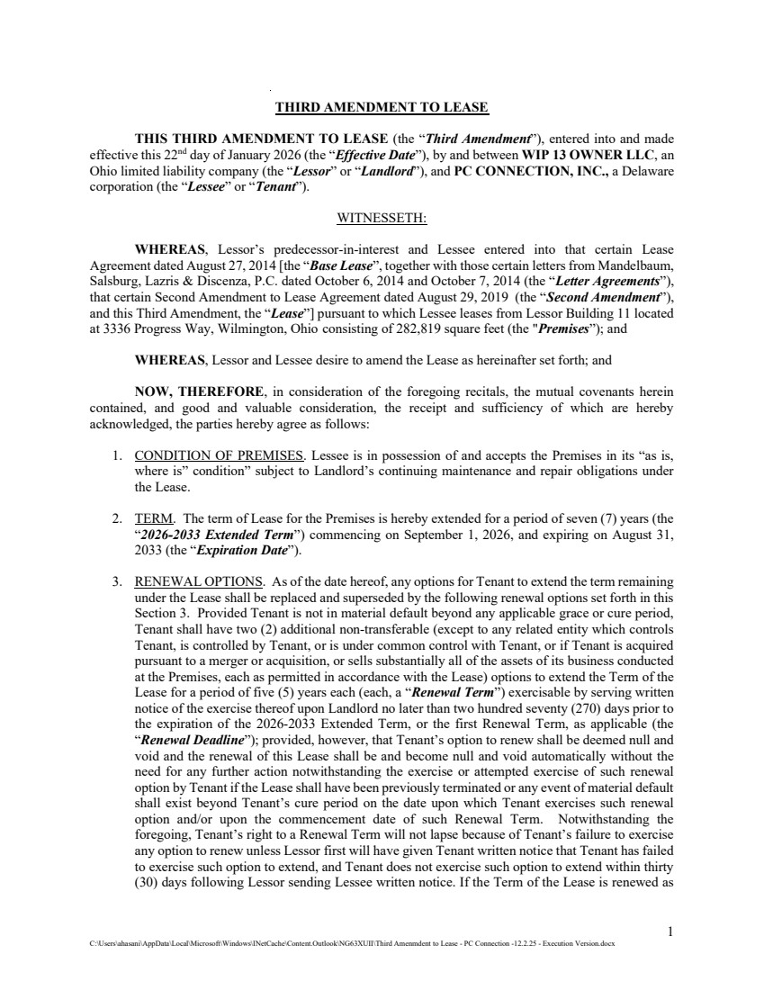 | 1 C:\Users\ahasani\AppData\Local\Microsoft\Windows\INetCache\Content.Outlook\NG63XUII\Third Amenmdent to Lease - PC Connection -12.2.25 - Execution Version.docx THIRD AMENDMENT TO LEASE THIS THIRD AMENDMENT TO LEASE (the “Third Amendment”), entered into and made effective this 22nd day of January 2026 (the “Effective Date”), by and between WIP 13 OWNER LLC, an Ohio limited liability company (the “Lessor” or “Landlord”), and PC CONNECTION, INC., a Delaware corporation (the “Lessee” or “Tenant”). WITNESSETH: WHEREAS, Lessor’s predecessor-in-interest and Lessee entered into that certain Lease Agreement dated August 27, 2014 [the “Base Lease”, together with those certain letters from Mandelbaum, Salsburg, Lazris & Discenza, P.C. dated October 6, 2014 and October 7, 2014 (the “Letter Agreements”), that certain Second Amendment to Lease Agreement dated August 29, 2019 (the “Second Amendment”), and this Third Amendment, the “Lease”] pursuant to which Lessee leases from Lessor Building 11 located at 3336 Progress Way, Wilmington, Ohio consisting of 282,819 square feet (the "Premises”); and WHEREAS, Lessor and Lessee desire to amend the Lease as hereinafter set forth; and NOW, THEREFORE, in consideration of the foregoing recitals, the mutual covenants herein contained, and good and valuable consideration, the receipt and sufficiency of which are hereby acknowledged, the parties hereby agree as follows: 1. CONDITION OF PREMISES. Lessee is in possession of and accepts the Premises in its “as is, where is” condition” subject to Landlord’s continuing maintenance and repair obligations under the Lease. 2. TERM. The term of Lease for the Premises is hereby extended for a period of seven (7) years (the “2026-2033 Extended Term”) commencing on September 1, 2026, and expiring on August 31, 2033 (the “Expiration Date”). 3. RENEWAL OPTIONS. As of the date hereof, any options for Tenant to extend the term remaining under the Lease shall be replaced and superseded by the following renewal options set forth in this Section 3. Provided Tenant is not in material default beyond any applicable grace or cure period, Tenant shall have two (2) additional non-transferable (except to any related entity which controls Tenant, is controlled by Tenant, or is under common control with Tenant, or if Tenant is acquired pursuant to a merger or acquisition, or sells substantially all of the assets of its business conducted at the Premises, each as permitted in accordance with the Lease) options to extend the Term of the Lease for a period of five (5) years each (each, a “Renewal Term”) exercisable by serving written notice of the exercise thereof upon Landlord no later than two hundred seventy (270) days prior to the expiration of the 2026-2033 Extended Term, or the first Renewal Term, as applicable (the “Renewal Deadline”); provided, however, that Tenant’s option to renew shall be deemed null and void and the renewal of this Lease shall be and become null and void automatically without the need for any further action notwithstanding the exercise or attempted exercise of such renewal option by Tenant if the Lease shall have been previously terminated or any event of material default shall exist beyond Tenant’s cure period on the date upon which Tenant exercises such renewal option and/or upon the commencement date of such Renewal Term. Notwithstanding the foregoing, Tenant’s right to a Renewal Term will not lapse because of Tenant’s failure to exercise any option to renew unless Lessor first will have given Tenant written notice that Tenant has failed to exercise such option to extend, and Tenant does not exercise such option to extend within thirty (30) days following Lessor sending Lessee written notice. If the Term of the Lease is renewed as
 | 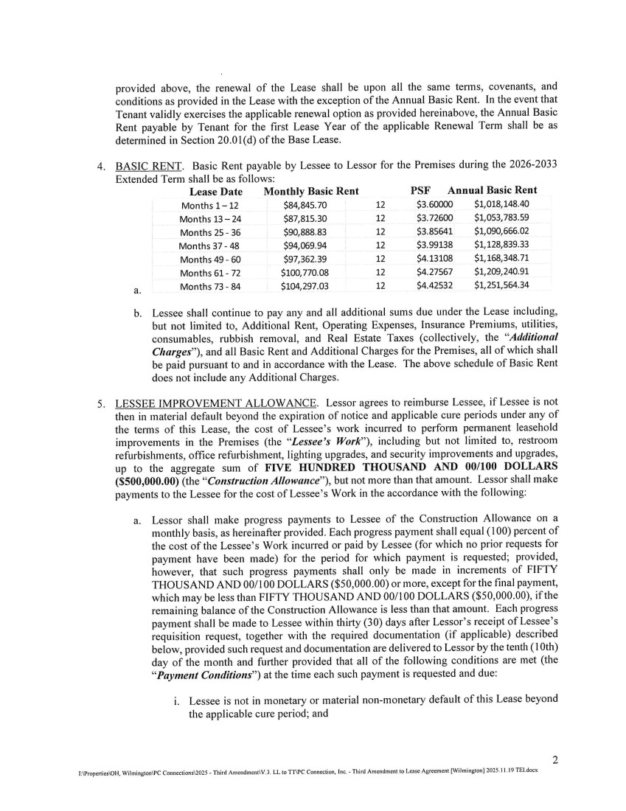 | provided above, the renewal of the Lease shall be upon all the same terms, covenants, and conditions as provided in the Lease with the exception of the Annual Basic Rent. In the event that Tenant validly exercises the applicable renewal option as provided hereinabove, the Annual Basic Rent payable by Tenant for the first Lease Year of the applicable Renewal Term shall be as determined in Section 20.0 1(d) of the Base Lease. BASIC RENT. Basic Rent payable by Lessee to Lessor for the Premises during the 2026-2033 Extended Term shall be as follows: Lease Date Monthly Basic Rent PSF Annual Basic Rent Months 1-12 $84,845.70 12 $360000 $1,018,148.40 Months 13-24 $87,815.30 12 $372600 $1,053,783.59 Months 25 - 36 $90,888.83 12 $385641 $1,090,666.02 Months 37-48 $94,069.94 12 $399138 $1,128,839.33 Months 49-60 $97,362.39 12 $413108 $1,168,348.71 Months 61-72 $100,770.08 12 $4.27567 $1,209,240.91 Months 73 - 84 $104,297.03 12 $4.42532 $1,251,564.34 a. b. Lessee shall continue to pay any and all additional sums due under the Lease including, but not limited to, Additional Rent, Operating Expenses, Insurance Premiums, utilities, consumables, rubbish removal, and Real Estate Taxes (collectively, the "Additional charges"), and all Basic Rent and Additional Charges for the Premises, all of which shall be paid pursuant to and in accordance with the Lease. The above schedule of Basic Rent does not include any Additional Charges. LESSEE IMPROVEMENT ALLOWANCE. Lessor agrees to reimburse Lessee, if Lessee is not then in material default beyond the expiration of notice and applicable cure periods under any of the terms of this Lease, the cost of Lessee's work incurred to perform permanent leasehold improvements in the Premises (the "Lessee's Work"), including but not limited to, restroom refurbishments, office refurbishment, lighting upgrades, and security improvements and upgrades, up to the aggregate sum of FIVE HUNDRED THOUSAND AND 00/100 DOLLARS ($500,000.00) (the "Construction Allowance"), but not more than that amount. Lessor shall make payments to the Lessee for the cost of Lessee's Work in the accordance with the following: a. Lessor shall make progress payments to Lessee of the Construction Allowance on a monthly basis, as hereinafter provided. Each progress payment shall equal (100) percent of the cost of the Lessee's Work incurred or paid by Lessee (for which no prior requests for payment have been made) for the period for which payment is requested; provided, however, that such progress payments shall only be made in increments of FIFTY THOUSAND AND 00/100 DOLLARS ($50,000.00) or more, except for the final payment, which may be less than FIFTY THOUSAND AND 00/100 DOLLARS ($50,000.00), if the remaining balance of the Construction Allowance is less than that amount. Each progress payment shall be made to Lessee within thirty (30) days after Lessor's receipt of Lessee's requisition request, together with the required documentation (if applicable) described below, provided such request and documentation are delivered to Lessor by the tenth (10th) day of the month and further provided that all of the following conditions are met (the "Payment conditions") at the time each such payment is requested and due: i. Lessee is not in monetary or material non-monetary default of this Lease beyond the applicable cure period; and 2 :\I'roperties\OH, V'iIoitgtoit\PC Connection s\2025 . Third A,sscodmcnt\V.3, LL to TT\PC Connection, Inc. - Third Amendment to Lease Agreement [Wilmington] 2025.11 19 TEI.docx
 | 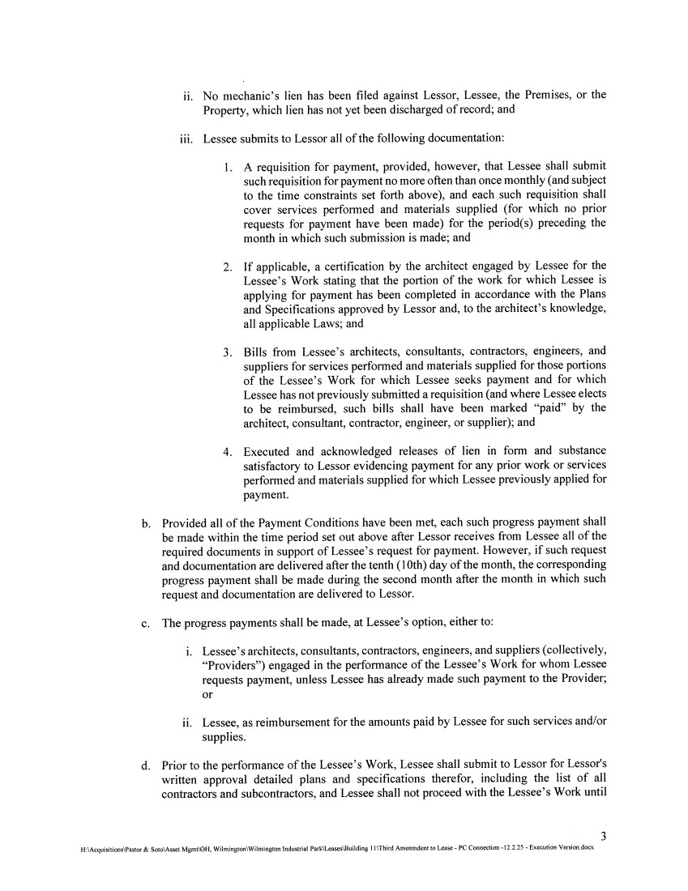 | ii. No mechanic's lien has been filed against Lessor, Lessee, the Premises, or the Property, which lien has not yet been discharged of record; and iii. Lessee submits to Lessor all of the following documentation: A requisition for payment, provided, however, that Lessee shall submit such requisition for payment no more often than once monthly (and subject to the time constraints set forth above), and each such requisition shall cover services performed and materials supplied (for which no prior requests for payment have been made) for the period(s) preceding the month in which such submission is made; and 2. If applicable, a certification by the architect engaged by Lessee for the Lessee's Work stating that the portion of the work for which Lessee is applying for payment has been completed in accordance with the Plans and Specifications approved by Lessor and, to the architect's knowledge, all applicable Laws; and 3. Bills from Lessee's architects, consultants, contractors, engineers, and suppliers for services performed and materials supplied for those portions of the Lessee's Work for which Lessee seeks payment and for which Lessee has not previously submitted a requisition (and where Lessee elects to be reimbursed, such bills shall have been marked "paid" by the architect, consultant, contractor, engineer, or supplier); and 4. Executed and acknowledged releases of lien in form and substance satisfactory to Lessor evidencing payment for any prior work or services performed and materials supplied for which Lessee previously applied for payment. b. Provided all of the Payment Conditions have been met, each such progress payment shall be made within the time period set out above after Lessor receives from Lessee all of the required documents in support of Lessee's request for payment. However, if such request and documentation are delivered after the tenth (10th) day of the month, the corresponding progress payment shall be made during the second month after the month in which such request and documentation are delivered to Lessor. c. The progress payments shall be made, at Lessee's option, either to: i. Lessee's architects, consultants, contractors, engineers, and suppliers (collectively, "Providers") engaged in the performance of the Lessee's Work for whom Lessee requests payment, unless Lessee has already made such payment to the Provider; or ii. Lessee, as reimbursement for the amounts paid by Lessee for such services and/or supplies. d. Prior to the performance of the Lessee's Work, Lessee shall submit to Lessor for Lessor's written approval detailed plans and specifications therefor, including the list of all contractors and subcontractors, and Lessee shall not proceed with the Lessee's Work until 3 H:Acquisiuons\Pastor& Soo\Asset Mgtnt\OH. Wilmington\Wilmington Industrial ParkLuacs\Building I I\Third Amenindentlo Lease - PC Connection -12.2.25 -Execution Version.docx
 | 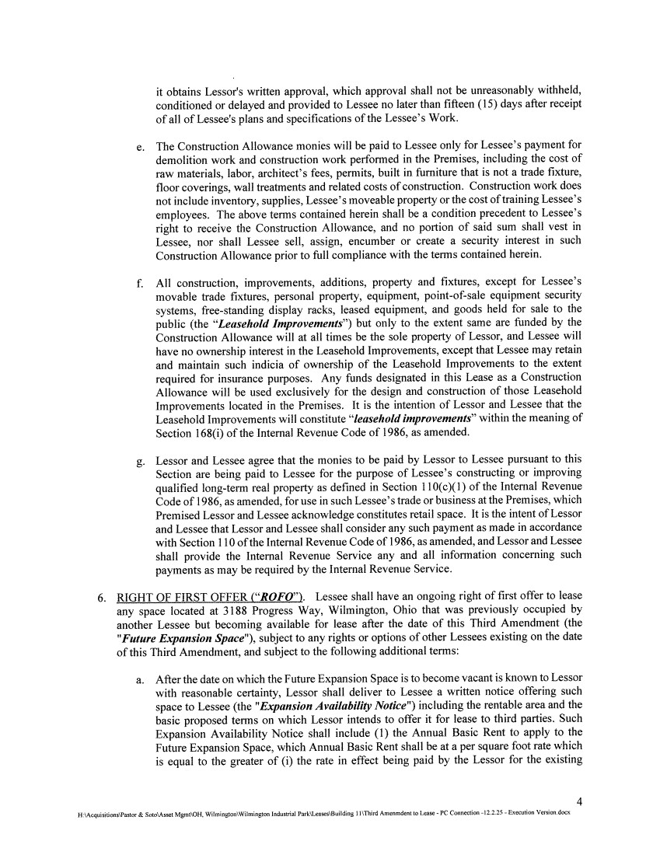 | it obtains Lessor's written approval, which approval shall not be unreasonably withheld, conditioned or delayed and provided to Lessee no later than fifteen (15) days after receipt of all of Lessee's plans and specifications of the Lessee's Work. e. The Construction Allowance monies will be paid to Lessee only for Lessee's payment for demolition work and construction work performed in the Premises, including the cost of raw materials, labor, architect's fees, permits, built in furniture that is not a trade fixture, floor coverings, wall treatments and related costs of construction. Construction work does not include inventory, supplies, Lessee's moveable property or the cost of training Lessee's employees. The above terms contained herein shall be a condition precedent to Lessee's right to receive the Construction Allowance, and no portion of said sum shall vest in Lessee, nor shall Lessee sell, assign, encumber or create a security interest in such Construction Allowance prior to full compliance with the terms contained herein. All construction, improvements, additions, property and fixtures, except for Lessee's movable trade fixtures, personal property, equipment, point-of-sale equipment security systems, free-standing display racks, leased equipment, and goods held for sale to the public (the "Leasehold Improvements") but only to the extent same are funded by the Construction Allowance will at all times be the sole property of Lessor, and Lessee will have no ownership interest in the Leasehold Improvements, except that Lessee may retain and maintain such indicia of ownership of the Leasehold Improvements to the extent required for insurance purposes. Any funds designated in this Lease as a Construction Allowance will be used exclusively for the design and construction of those Leasehold Improvements located in the Premises. It is the intention of Lessor and Lessee that the Leasehold Improvements will constitute "leasehold improvements" within the meaning of Section 168(i) of the internal Revenue Code of 1986, as amended. g. Lessor and Lessee agree that the monies to be paid by Lessor to Lessee pursuant to this Section are being paid to Lessee for the purpose of Lessee's constructing or improving qualified long-term real property as defined in Section 110(c)(l) of the Internal Revenue Code of 1986, as amended, for use in such Lessee's trade or business at the Premises, which Premised Lessor and Lessee acknowledge constitutes retail space. It is the intent of Lessor and Lessee that Lessor and Lessee shall consider any such payment as made in accordance with Section 110 of the Internal Revenue Code of 1986, as amended, and Lessor and Lessee shall provide the Internal Revenue Service any and all information concerning such payments as may be required by the Internal Revenue Service. 6. RIGHT OF FIRST OFFER ("ROFO"). Lessee shall have an ongoing right of first offer to lease any space located at 3188 Progress Way, Wilmington, Ohio that was previously occupied by another Lessee but becoming available for lease after the date of this Third Amendment (the "Future Expansion Space"), subject to any rights or options of other Lessees existing on the date of this Third Amendment, and subject to the following additional terms: a. After the date on which the Future Expansion Space is to become vacant is known to Lessor with reasonable certainty, Lessor shall deliver to Lessee a written notice offering such space to Lessee (the "Expansion Availability Notice") including the rentable area and the basic proposed terns on which Lessor intends to offer it for lease to third parties. Such Expansion Availability Notice shall include (1) the Annual Basic Rent to apply to the Future Expansion Space, which Annual Basic Rent shall be at a per square foot rate which is equal to the greater of (i) the rate in effect being paid by the Lessor for the existing 4 H:Acquisitions\Pastor& SotoAssct Mgrnt\OH, WflmingtonWiImington Industrial Park\Leases\Building 11\Third Amenmdentto Lease -PC Connection -12.2.25 -Execution Veision.docx
 | 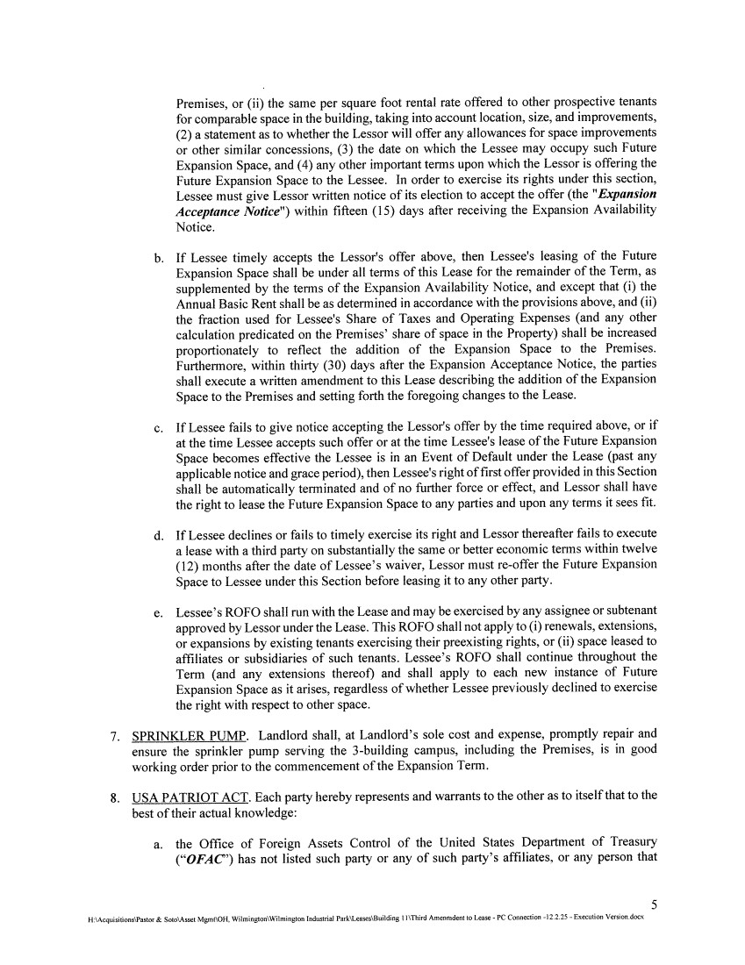 | Premises, or (ii) the same per square foot rental rate offered to other prospective tenants for comparable space in the building, taking into account location, size, and improvements, (2) a statement as to whether the Lessor will offer any allowances for space improvements or other similar concessions, (3) the date on which the Lessee may occupy such Future Expansion Space, and (4) any other important terms upon which the Lessor is offering the Future Expansion Space to the Lessee. In order to exercise its rights under this section, Lessee must give Lessor written notice of its election to accept the offer (the "Expansion Acceptance Notice") within fifteen (15) days after receiving the Expansion Availability Notice. b. If Lessee timely accepts the Lessor's offer above, then Lessee's leasing of the Future Expansion Space shall be under all terms of this Lease for the remainder of the Term, as supplemented by the terms of the Expansion Availability Notice, and except that (i) the Annual Basic Rent shall be as determined in accordance with the provisions above, and (ii) the fraction used for Lessee's Share of Taxes and Operating Expenses (and any other calculation predicated on the Premises' share of space in the Property) shall be increased proportionately to reflect the addition of the Expansion Space to the Premises. Furthermore, within thirty (30) days after the Expansion Acceptance Notice, the parties shall execute a written amendment to this Lease describing the addition of the Expansion Space to the Premises and setting forth the foregoing changes to the Lease. c. If Lessee fails to give notice accepting the Lessor's offer by the time required above, or if at the time Lessee accepts such offer or at the time Lessee's lease of the Future Expansion Space becomes effective the Lessee is in an Event of Default under the Lease (past any applicable notice and grace period), then Lessee's right of first offer provided in this Section shall be automatically terminated and of no further force or effect, and Lessor shall have the right to lease the Future Expansion Space to any parties and upon any terms it sees fit. d. If Lessee declines or fails to timely exercise its right and Lessor thereafter fails to execute a lease with a third party on substantially the same or better economic terms within twelve (12) months after the date of Lessee's waiver, Lessor must re-offer the Future Expansion Space to Lessee under this Section before leasing it to any other party. e. Lessee's ROFO shall run with the Lease and may be exercised by any assignee or subtenant approved by Lessor under the Lease. This ROFO shall not apply to (i) renewals, extensions, or expansions by existing tenants exercising their preexisting rights, or (ii) space leased to affiliates or subsidiaries of such tenants. Lessee's ROFO shall continue throughout the Term (and any extensions thereof) and shall apply to each new instance of Future Expansion Space as it arises, regardless of whether Lessee previously declined to exercise the right with respect to other space. 7. SPRINKLER PUMP. Landlord shall, at Landlord's sole cost and expense, promptly repair and ensure the sprinkler pump serving the 3-building campus, including the Premises, is in good working order prior to the commencement of the Expansion Term. 8. USA PATRIOT ACT. Each party hereby represents and warrants to the other as to itself that to the best of their actual knowledge: a. the Office of Foreign Assets Control of the United States Department of Treasury ("OFAC') has not listed such party or any of such party's affiliates, or any person that 5 H:\Acquisiuons\Pastor & SotoAsset Mg,nt\OH. Wilminglon\Wilmington industrial Park\Leues\Buildrng I I\Third Anenmdent to Lease - PC Connection -12.2.25 -Execution Venion.docx
 | 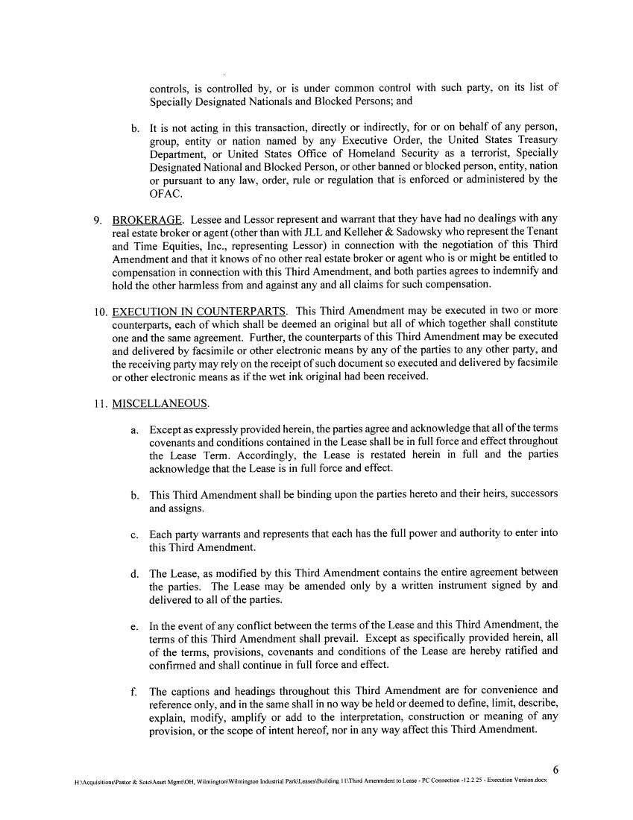 | controls, is controlled by, or is under common control with such party, on its list of Specially Designated Nationals and Blocked Persons; and b. it is not acting in this transaction, directly or indirectly, for or on behalf of any person, group, entity or nation named by any Executive Order, the United States Treasury Department, or United States Office of Homeland Security as a terrorist, Specially Designated National and Blocked Person, or other banned or blocked person, entity, nation or pursuant to any law, order, rule or regulation that is enforced or administered by the OFAC. 9. BROKERAGE. Lessee and Lessor represent and warrant that they have had no dealings with any real estate broker or agent (other than with JLL and Kelleher & Sadowsky who represent the Tenant and Time Equities, Inc., representing Lessor) in connection with the negotiation of this Third Amendment and that it knows of no other real estate broker or agent who is or might be entitled to compensation in connection with this Third Amendment, and both parties agrees to indemnify and hold the other harmless from and against any and all claims for such compensation. 10. EXECUTION IN COUNTERPARTS. This Third Amendment may be executed in two or more counterparts, each of which shall be deemed an original but all of which together shall constitute one and the same agreement. Further, the counterparts of this Third Amendment may be executed and delivered by facsimile or other electronic means by any of the parties to any other party, and the receiving party may rely on the receipt of such document so executed and delivered by facsimile or other electronic means as if the wet ink original had been received. 11. MISCELLANEOUS. a. Except as expressly provided herein, the parties agree and acknowledge that all of the terms covenants and conditions contained in the Lease shall be in full force and effect throughout the Lease Term. Accordingly, the Lease is restated herein in full and the parties acknowledge that the Lease is in full force and effect. b. This Third Amendment shall be binding upon the parties hereto and their heirs, successors and assigns. c. Each party warrants and represents that each has the full power and authority to enter into this Third Amendment. d. The Lease, as modified by this Third Amendment contains the entire agreement between the parties. The Lease may be amended only by a written instrument signed by and delivered to all of the parties. e. In the event of any conflict between the terms of the Lease and this Third Amendment, the terms of this Third Amendment shall prevail. Except as specifically provided herein, all of the terms, provisions, covenants and conditions of the Lease are hereby ratified and confirmed and shall continue in full force and effect. f. The captions and headings throughout this Third Amendment are for convenience and reference only, and in the same shall in no way be held or deemed to define, limit, describe, explain, modify, amplify or add to the interpretation, construction or meaning of any provision, or the scope of intent hereof, nor in any way affect this Third Amendment. 6 H:\Acquisitions\Pstor& Soto\Asset MgmtOH, Wilrninglon\Wilmington Industrial Park\Leases\Building I I\Third Ainenmdent to Lease -PC Connection .122.25 -Execution Veesion.docx
 |  | g. Al! terms not defined in this Third Amendment shall have the respective meanings ascribed to them in the Lease. [SIGNATURES APPEAR ON THE FOLLOWING PAGE] [REMAINDER OF THE PAGE INTENTIONALLY LEFT BLANK] H:\Acquisitions\Pastor& Soto\Assct MgmAOH. Wilmington\Wdmington Industrial Park\Leaseu\Boilding 11\Third Amenmdent to Lease -PC Connection -12.2.25 -Execution Version.docx
 | 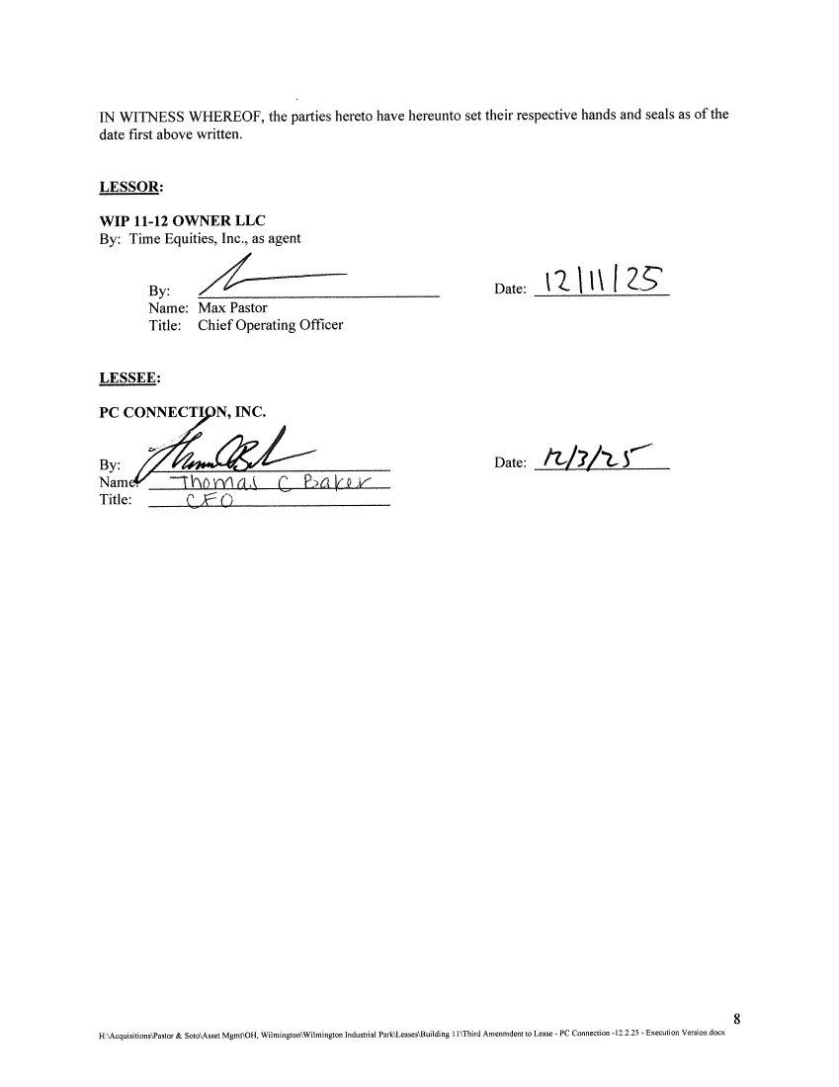 | IN WITNESS WHEREOF, the parties hereto have hereunto set their respective hands and seals as of the date first above written. LESSOR: WIP 11-12 OWNER LLC By: Time Equities, Inc., as agent By: Name: Max Pastor Title: Chief Operating Officer Date: 1211 I Z LESSEE: PC CONNECTI N, INC. By: Date: Nam. On1 Cb a LV Title: 8 H:'AcquisitionsPastor & Soto\Asset MgmA0H. Wilmington\Wilmington Industrial Park\ ca Building I l\Third Amenmdcnt to Lease - PC Connection -12.2.25 - Execution Version.docx
 | 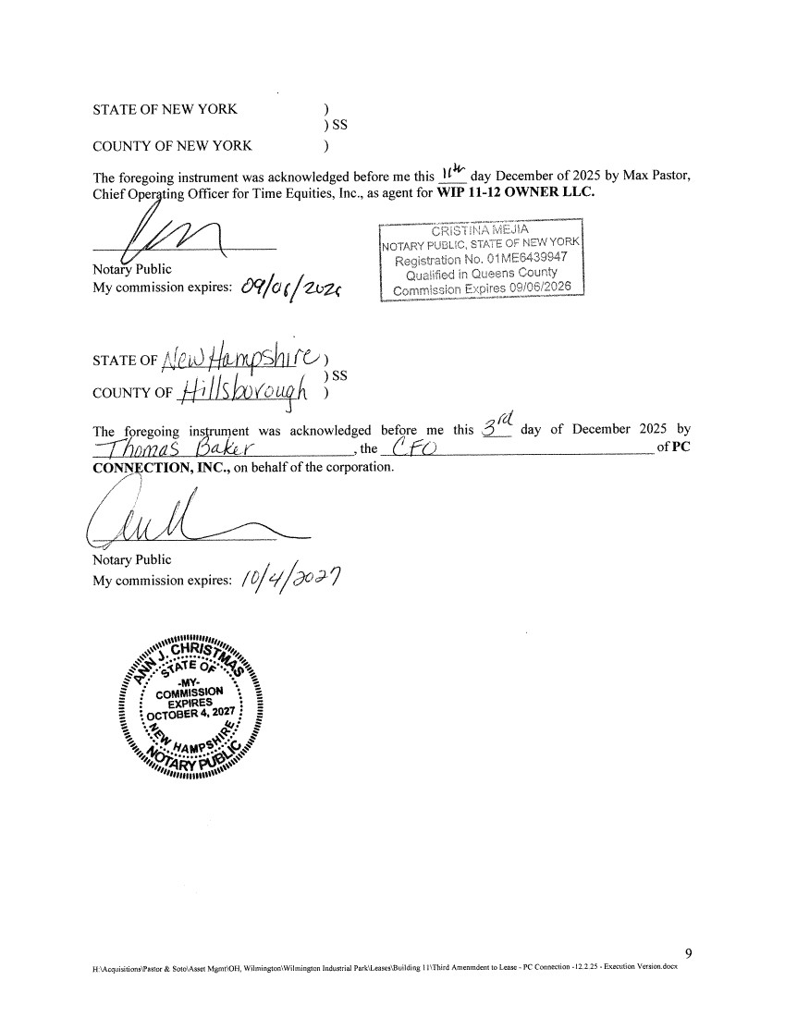 | STATE OF NEW YORK ) ) SS COUNTY OF NEW YORK The foregoing instrument was acknowledged before me this 114 day December of 2025 by Max Pastor, Chief Oper ting Officer for Time Equities, Inc., as agent for WIP 11-12 OWNER LLC. r IsTfF NOTARY PUBLIC, STATE OF NEW YORK Registration No. 01ME6439947 Notary Public I Qualified in Queens County My commission expires: j Commission Expires O92 . !J STATE OF A1 ?4-P1I (C1) ) SS COUNTY OF ilJskxwou The foregoing instrument was acknowledged before me this day of December 2025 by 7iinaS5LkK__ ,the (f(i)_ of PC CONNCTION, INC., on behalf of the corporation. Notary Public My commission expires: /O/q/do?9 Ci my-I COMM EXPIRES OCTOBER 4, 2027: 4,f 9 H \AcquisitionsWastor& Soto\Assei Mgnst\OH, WslniintonWiImington Industrial Parl\Leases\BuiIdin8 lI\Third Aniernndent to Lease - PC Connection -12.225 - Execution Version.docx
Exhibit 10.3
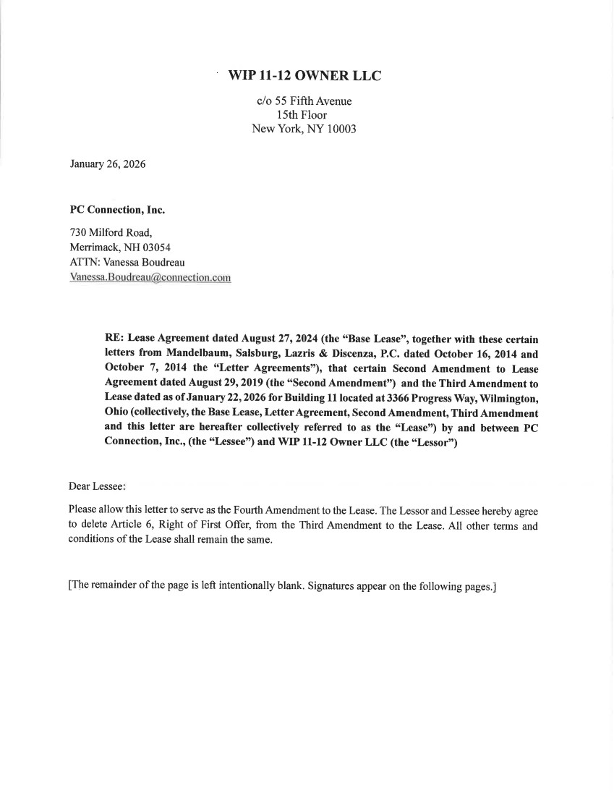
 | 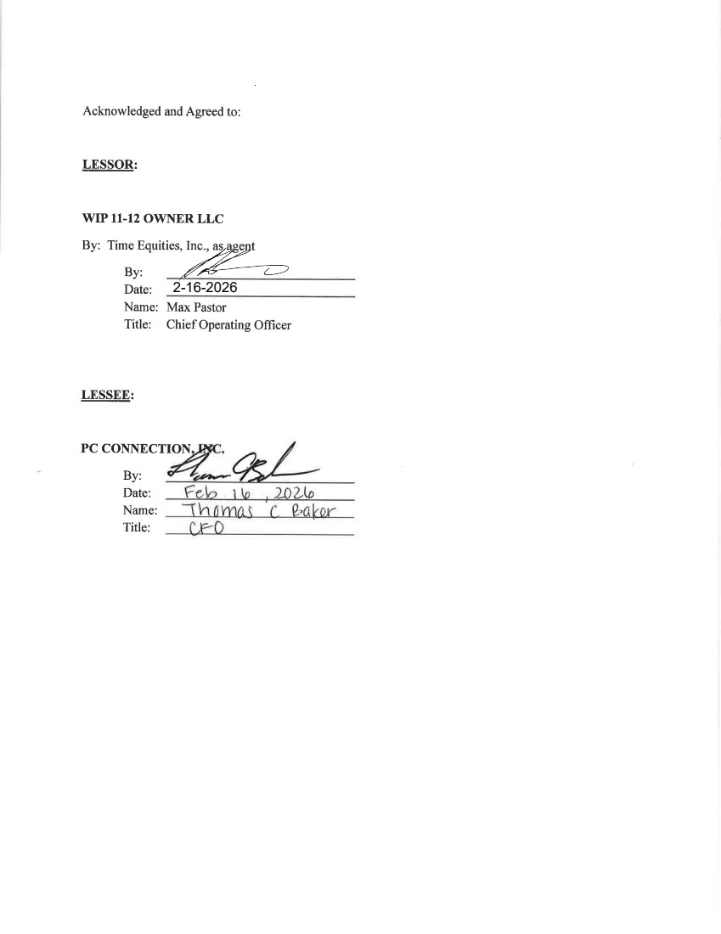 | 2-16-2026
Exhibit 31.1
CERTIFICATION
I, Timothy J. McGrath, certify that:
1. | I have reviewed this Quarterly Report on Form 10-Q of PC Connection, Inc.;
​
2. | Based on my knowledge, this report does not contain any untrue statement of a material fact or omit to state a material fact necessary to make the statements made, in light of the circumstances under which such statements were made, not misleading with respect to the period covered by this report;
​
3. | Based on my knowledge, the financial statements, and other financial information included in this report, fairly present in all material respects the financial condition, results of operations, and cash flows of the registrant as of, and for, the periods presented in this report;
​
4. | The registrant’s other certifying officer and I are responsible for establishing and maintaining disclosure controls and procedures (as defined in Exchange Act Rules 13a-15(e) and 15d-15(e)) and internal control over financial reporting (as defined in Exchange Act Rules 13a-15(f) and 15d-15(f)) for the registrant and have:
 | a) | Designed such disclosure controls and procedures, or caused such disclosure controls and procedures to be designed under our supervision, to ensure that material information relating to the registrant, including its consolidated subsidiaries, is made known to us by others within those entities, particularly during the period in which this report is being prepared;
 | b) | Designed such internal control over financial reporting, or caused such internal control over financial reporting to be designed under our supervision, to provide reasonable assurance regarding the reliability of financial reporting and the preparation of financial statements for external purposes in accordance with generally accepted accounting principles;
 | c) | Evaluated the effectiveness of the registrant’s disclosure controls and procedures and presented in this report our conclusions about the effectiveness of the disclosure controls and procedures, as of the end of the period covered by this report based on such evaluation; and
 | d) | Disclosed in this report any change in the registrant’s internal control over financial reporting that occurred during the registrant’s most recent fiscal quarter (the registrant’s fourth fiscal quarter in the case of an annual report) that has materially affected, or is reasonably likely to materially affect, the registrant’s internal control over financial reporting; and
​
5. | The registrant’s other certifying officer and I have disclosed, based on our most recent evaluation of internal control over financial reporting, to the registrant’s auditors and the audit committee of the registrant’s board of directors (or persons performing the equivalent functions):
 | a) | All significant deficiencies and material weaknesses in the design or operation of internal control over financial reporting which are reasonably likely to adversely affect the registrant’s ability to record, process, summarize, and report financial information; and
 | b) | Any fraud, whether or not material, that involves management or other employees who have a significant role in the registrant’s internal control over financial reporting.
​
​
​
​
6 | ​ | ​
Date: April 29, 2026 | ​ | /s/ TIMOTHY J. MCGRATH
​ | ​ | Timothy J. McGrath
​ | ​ | President and Chief Executive Officer (Principal Executive Officer)
​

Exhibit 31.2
CERTIFICATION
I, Thomas C. Baker, certify that:
1. | I have reviewed this Quarterly Report on Form 10-Q of PC Connection, Inc.;
​
2. | Based on my knowledge, this report does not contain any untrue statement of a material fact or omit to state a material fact necessary to make the statements made, in light of the circumstances under which such statements were made, not misleading with respect to the period covered by this report;
​
3. | Based on my knowledge, the financial statements, and other financial information included in this report, fairly present in all material respects the financial condition, results of operations, and cash flows of the registrant as of, and for, the periods presented in this report;
​
4. | The registrant’s other certifying officer and I are responsible for establishing and maintaining disclosure controls and procedures (as defined in Exchange Act Rules 13a-15(e) and 15d-15(e)) and internal control over financial reporting (as defined in Exchange Act Rules 13a-15(f) and 15d-15(f)) for the registrant and have:
​
 | a) | Designed such disclosure controls and procedures, or caused such disclosure controls and procedures to be designed under our supervision, to ensure that material information relating to the registrant, including its consolidated subsidiaries, is made known to us by others within those entities, particularly during the period in which this report is being prepared;
 | b) | Designed such internal control over financial reporting, or caused such internal control over financial reporting to be designed under our supervision, to provide reasonable assurance regarding the reliability of financial reporting and the preparation of financial statements for external purposes in accordance with generally accepted accounting principles;
 | c) | Evaluated the effectiveness of the registrant’s disclosure controls and procedures and presented in this report our conclusions about the effectiveness of the disclosure controls and procedures, as of the end of the period covered by this report based on such evaluation; and
 | d) | Disclosed in this report any change in the registrant’s internal control over financial reporting that occurred during the registrant’s most recent fiscal quarter (the registrant’s fourth fiscal quarter in the case of an annual report) that has materially affected, or is reasonably likely to materially affect, the registrant’s internal control over financial reporting; and
​
5. | The registrant’s other certifying officer and I have disclosed, based on our most recent evaluation of internal control over financial reporting, to the registrant’s auditors and the audit committee of the registrant’s board of directors (or persons performing the equivalent functions):
​
 | a) | All significant deficiencies and material weaknesses in the design or operation of internal control over financial reporting which are reasonably likely to adversely affect the registrant’s ability to record, process, summarize, and report financial information; and
 | b) | Any fraud, whether or not material, that involves management or other employees who have a significant role in the registrant’s internal control over financial reporting.
​
​
​
​
​ | ​ | ​
Date: April 29, 2026 | ​ | /s/ THOMAS C. BAKER
​ | ​ | Thomas C. Baker
​ | ​ | Senior Vice President, Chief Financial Officer and Treasurer (Principal Financial and Accounting Officer)
​

Exhibit 32.1
CERTIFICATION PURSUANT TO 18 U.S.C. SECTION 1350,
AS ADOPTED PURSUANT TO
SECTION 906 OF THE SARBANES-OXLEY ACT OF 2002
In connection with the Quarterly Report on Form 10-Q of PC Connection, Inc. (the “Company”) for the period ended March 31, 2026 as filed with the Securities and Exchange Commission on the date hereof (the “Report”), the undersigned, Timothy J. McGrath, President and Chief Executive Officer of the Company, hereby certifies, pursuant to 18 U.S.C. Section 1350, that to the best of his knowledge:
 | (1) | the Report fully complies with the requirements of Section 13(a) or 15(d) of the Securities Exchange Act of 1934; and
​
 | (2) | the information contained in the Report fairly presents, in all material respects, the financial condition and results of operations of the Company.
​
​
​
​
​
​ | ​ | ​
Date: April 29, 2026 | ​ | /s/ TIMOTHY J. MCGRATH
​ | ​ | Timothy J. McGrath
​ | ​ | President and Chief Executive Officer (Principal Executive Officer)
​

Exhibit 32.2
CERTIFICATION PURSUANT TO 18 U.S.C. SECTION 1350,
AS ADOPTED PURSUANT TO
SECTION 906 OF THE SARBANES-OXLEY ACT OF 2002
In connection with the Quarterly Report on Form 10-Q of PC Connection, Inc. (the “Company”) for the period ended March 31, 2026 as filed with the Securities and Exchange Commission on the date hereof (the “Report”), the undersigned, Thomas C. Baker, Senior Vice President, Chief Financial Officer and Treasurer of the Company, hereby certifies, pursuant to 18 U.S.C. Section 1350, that to the best of his knowledge:
 | (1) | the Report fully complies with the requirements of Section 13(a) or 15(d) of the Securities Exchange Act of 1934; and
​
 | (2) | the information contained in the Report fairly presents, in all material respects, the financial condition and results of operations of the Company.
​
​
​
​
​
​ | ​ | ​
Date: April 29, 2026 | ​ | /s/ THOMAS C. BAKER
​ | ​ | Thomas C. Baker
​ | ​ | Senior Vice President, Chief Financial Officer and Treasurer (Principal Financial and Accounting Officer)
​

